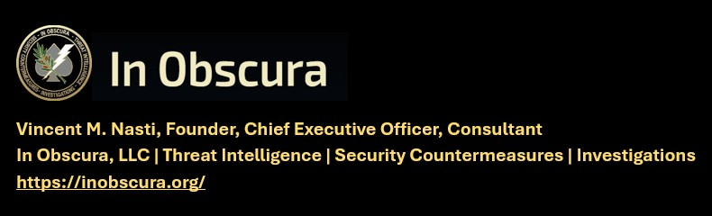

(TLP-C) ///FLASH/// SYNAGOGUE (2) ATTEMPT INFILTRATIONS, IVO BALTIMORE 19 June 2026
KNOW THE TARGET – WATCH THE TARGET – LOOK DEEPER -EXPECT THE UNEXPECTED
1 Chronicles 16:21-23
²² “Touch not Mine anointed and do My prophets no harm.”
²³ Sing unto the Lord, all the earth; show forth from day to day His salvation.
IN OBSCURA THEAT LEVEL – IMMINENT
---------------------------------------------------------------------------------------------------------------
CAVEAT: THIS INTELLIGENCE PRODUCT RELIES ON OPEN-SOURCE MEDIA OR GOVERNMENT RELEASED UNCLASIFIED INFORMATION. RECOMMENDED ACTIONS ARE INCLUDED FOR CLIENTS FOR INFORMATION AND ACTIONS DEEMED APPROPRIATE.
---------------------------------------------------------------------------------------------------------------
IMMEDIATE ACTION
Clergy and Church Security are to take this raw intelligence exceptionally seriously and take appropriate increased security countermeasures, especially increased surveillance. This of course includes synagogues. This also includes related Christian and Jewish actual and associated properties, related facilities, planned events and travel. Clergy and Security are advised to increase surveillance of your residences. Expect the unexpected.

IN OBSCURA COMMENT
FLASH Traffic means actionable for guarded immediate dissemination for indications and warning to all clergy, staff and security elements. Usually this is raw intelligence, not further elaborated at dissemination. It is likely this was hostile contact, because it would not be reported if this was legitimate contact. In the Intel, CT world this is considered unsolicited contact. Two different synagogues are involved in the targeting which seems first, initiated by elicitation contact of a member of each congregation. No further information on details of how this occurred. The reported manner of contact suggest potential feigned urgency by the SUBJECTS.
It is noted that the person approached took appropriate action, possibly denying access to these targets. Kemp Mills is a named region of the urban suburb of Montgomery County, Maryland. It also has its own large police department It is also home to several thousand Jews as a bedroom community of the Washington. That this team was wearing uniforms is concerning and could indicate cover and technical proficiency. Consistent with the current insurgent-guerilla threat environment.

(QUOTE) SITREP ALERT for 19 June 2026 – Possible New Adversarial TTP
Noted in the 19 June 2026 security brief from the Community Security Service:
Two White men, between the ages of 16-20, identified themselves as "Kemp Mill Peace Officers", and approached a congregant near a synagogue, demanding the synagogue's access code and questioning his religious identity. That same evening, the individuals reportedly wore uniforms with an "ALTA" insignia, outside a different congregation and gained the access codes from children. CSS Volunteers - Kemp Mill, Maryland (Tuesday - 6/9/26)

Should a similar situation occur while you are on post, DO NOT ALLOW ENTRANCE TO THE BUILDING. Procure the individual’s (or individuals) credentials (Business Card, Operational Orders) and contact the issuing agency to certify their credibility.

Ask the agency to supply the name(s) of the individual(s) sent to your site. DO NOT give the name(s) of the individual (or individuals) at your door. The issuing agency should know who they sent to your site. Confirm with the name(s) on the individual’s (or individuals) business card(s). Note any hint of deception on the part of the agency as the “agency” may be a person in collusion with the possible scam.

If in question, call the local PD. Advise them of the situation. Ask if they had heard of the agency in question. Request a PD officer to your location if necessary. Do Not Allow Entrance to individual(s) waiting outside until thoroughly verified.

“But if the watchman sees the sword coming and does not blow the trumpet to warn the people and the sword comes and takes someone’s life, that person’s life will be lost because of the watchman’s sin.” – Ezekiel 33:6 (END QUOTE)
///END///

====================================================================
REQUEST WRITTEN PERMISSION, EMAIL, PRIOR TO DISSEMINATING ANY IN OBSCURA PRODUCTS OR INFORMATION.
TRAFFIC LIGHT PROTOCOL REQUIREMENTS FOR DISSEMINATION
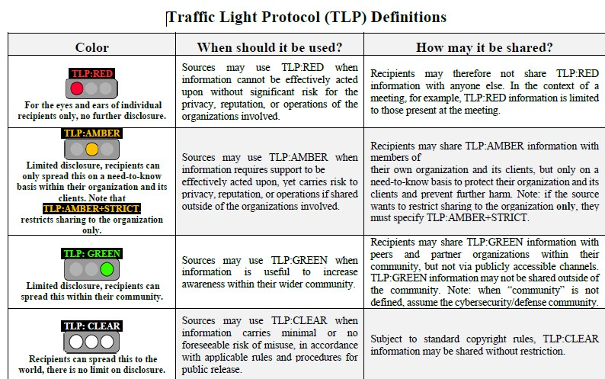

///END OF REPORT///

