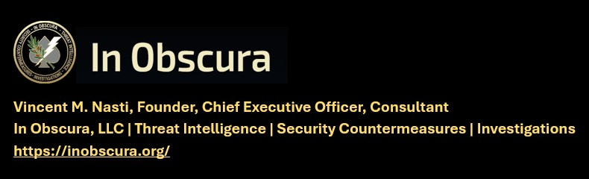

(TLP-C) FROM PROPAGANDA TO THE BATTLEFIELD: HOW AI IS MAKING TERRORIST ATTACKS MORE EFFECTIVE, 18 JULY 2026
KNOW THE TARGET – WATCH THE TARGET – LOOK DEEPER -EXPECT THE UNEXPECTED
Matthew 11:12 "And from the days of John the Baptist until now the kingdom of heaven suffereth violence, and the violent take it by force."
IN OBSCURA THEAT LEVEL – IMMINENT
---------------------------------------------------------------------------------------------------------------
CAVEAT: THIS INTELLIGENCE PRODUCT RELIES ON OPEN-SOURCE MEDIA OR GOVERNMENT RELEASED UNCLASIFIED INFORMATION. RECOMMENDED ACTIONS ARE INCLUDED FOR CLIENTS FOR INFORMATION AND ACTIONS DEEMED APPROPRIATE.
---------------------------------------------------------------------------------------------------------------
IN OBSCURA COMMENT
Operational and investigative experience over the decades exposed me to intelligence reporting which revealed the highly aggressive and very massive research, development, testing and evaluation (RDTE) by enemy intelligence. Experience also has shown me “terrorism” has been the incorrect term, to describe the genocidal and hegemonic proxy war with unending war crimes we have fought since well before 9/11. This is war and currently is raging with substantive infiltration and penetration of our country. The RDTE by these enemy groups is supplied with the intelligence cycle of espionage successes against the US and develops countermeasures to defeat what we presume are secure operations, technologies or countermeasures. One classic case was the Shoe Bomber. Very aware of our capabilities air travel security.

Umar Farouk Abdulmutallab—known colloquially as the “underwear bomber”—is the attempted suicide bomber from Nigeria who targeted a Detroit-bound airliner on Christmas Day, 2009. Umar Farouk Abdulmutallab—known colloquially as the “underwear bomber”—is the attempted suicide bomber from Nigeria who targeted a Detroit-bound airliner on Christmas Day, 2009.*Abdulmutallab—who had traveled to Yemen to meet with al-Qaeda cleric Anwar al-Awlaki—pled guilty in October 2011 to eight counts related to the failed bombing, including attempted use of a weapon of mass destruction and conspiracy to commit an act of transnational terrorism.* Abdulmutallab is currently serving life in prison in Florence, Colorado. You can be assured this AI move is no different…

THE REPORT BY MARIA

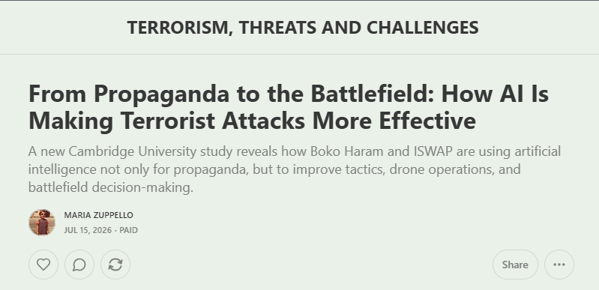
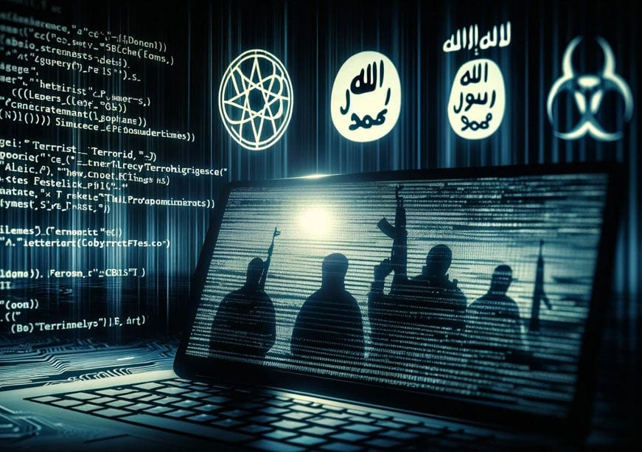

TERRORISM, THREATS AND CHALLENGES
From Propaganda to the Battlefield: How AI Is Making Terrorist Attacks More Effective
A new Cambridge University study reveals how Boko Haram and ISWAP are using artificial intelligence not only for propaganda, but to improve tactics, drone operations, and battlefield decision-making. MARIA ZUPPELLO Jul 15, 2026
https://mariazuppello.substack.com/p/from-propaganda-to-the-battlefield

For years, concerns about artificial intelligence and terrorism focused largely on propaganda. Extremist groups were expected to use AI to generate recruitment videos, spread disinformation, and amplify their messages online. While those fears remain valid, emerging evidence suggests a far more troubling evolution: terrorist organizations are increasingly using AI not just to influence minds, but to improve the effectiveness of their operations on the battlefield.

New research from University of Cambridge reveals how this transformation is already underway. Based on extensive interviews with former members of Boko Haram and its offshoot, Islamic State West Africa Province, researchers found that militants have been using AI tools since 2023 to support operational decision-making. Fighters reportedly consulted AI systems to understand how to operate captured weapons, improve drone-delivered explosives, and refine tactical planning for attacks. Rather than creating entirely new methods of violence, AI is helping terrorist groups become more efficient, adaptive, and lethal.

The implications extend far beyond northeastern Nigeria. According to the 2026 edition of the Global Peace Index 2026, the militarization of artificial intelligence has become one of the defining characteristics of modern conflict. Drone strike incidents increased by an astonishing 115-fold between 2018 and 2025. During that period, 565 different armed actors—including insurgencies, criminal organizations, militias, and state militaries—conducted at least one drone attack. The widespread availability of commercial drones, combined with increasingly accessible AI systems, is lowering barriers that once separated sophisticated military capabilities from non-state actors.

What makes this trend particularly dangerous is that AI acts as a force multiplier. Terrorist groups do not need advanced laboratories, specialized engineers, or large research budgets to benefit from artificial intelligence. Many of the capabilities described by former ISWAP members involve using publicly available AI systems to analyze tactics, optimize operations, and extract technical knowledge. One fighter reportedly explained that AI-assisted analysis convinced commanders to abandon large-scale assaults involving hundreds of militants in favor of smaller, more coordinated units that suffered fewer casualties and achieved better results. In other words, AI is helping terrorist organizations learn faster and adapt more effectively.

The combination of AI and drones is especially concerning. Armed groups around the world have already demonstrated an ability to modify commercially available drones to conduct surveillance, deliver explosives, and strike targets with increasing precision.
The Nigerian case suggests that AI may now be helping militants improve those systems, making them more reliable and more difficult to counter. Similar dynamics have already been observed in conflicts such as the war in Ukraine, where artificial intelligence has accelerated targeting processes and expanded the role of autonomous systems. Technologies developed for conventional warfare inevitably diffuse beyond state actors, creating new opportunities for terrorist and criminal organizations.

The strategic consequences could be global. Historically, terrorist groups faced significant operational limitations: training took time, expertise was scarce, and tactical innovation often required direct experience. AI changes that equation. A relatively inexperienced militant can potentially access guidance that previously would have required months or years of training. As AI models become more capable, multilingual, and widely available, extremist groups operating in different regions could rapidly absorb lessons from conflicts thousands of miles away. Knowledge that once spread slowly through personal networks can now circulate almost instantly.

This acceleration comes at a time when governance mechanisms are struggling to keep pace. The Global Peace Index warns that technological advances are outstripping the legal, diplomatic, and regulatory frameworks designed to oversee them. AI-enabled systems are compressing decision cycles and reducing human oversight in military operations. In some contemporary conflicts, target-to-fire timelines have reportedly shrunk from approximately a day in the 1990s to mere seconds when autonomous selection systems are involved. While these developments are often discussed in the context of major powers, the same technological logic is increasingly visible among insurgent and terrorist actors.

The data from Nigeria underscores the urgency of the challenge. The 2026 edition of the Global Terrorism Index 2026 recorded the largest absolute increase in terrorism deaths worldwide in the country during 2025. Fatalities rose by 46 percent to 750 deaths, pushing Nigeria back to fourth place globally among the nations most affected by terrorism. ISWAP and Boko Haram were responsible for approximately 80 percent of those deaths. While many factors contribute to terrorist violence, the reported integration of AI into operational planning illustrates how emerging technologies can amplify existing threats.

The greatest danger may not be that AI enables entirely new forms of terrorism. Rather, it makes existing forms of violence more effective, more scalable, and more difficult to predict. Terrorist organizations no longer need cutting-edge weapons to become more dangerous. By using artificial intelligence to optimize tactics, improve coordination, and accelerate learning, they can increase the impact of capabilities they already possess.
That reality represents a significant shift in the global security landscape.

0 The question is no longer whether terrorists will use artificial intelligence. Evidence suggests they already are. The challenge for governments, technology companies, and international institutions is determining how to contain the security risks before AI-driven operational advantages become a standard feature of terrorist and insurgent warfare. As the technology becomes more accessible, the line separating sophisticated military capabilities from those available to non-state actors will continue to blur—and the consequences could be felt far beyond any single conflict zone. © 2026 MARIA ZUPPELLO///END///
====================================================================
REQUEST WRITTEN PERMISSION, EMAIL, PRIOR TO DISSEMINATING ANY IN OBSCURA PRODUCTS OR INFORMATION.
TRAFFIC LIGHT PROTOCOL REQUIREMENTS FOR DISSEMINATION

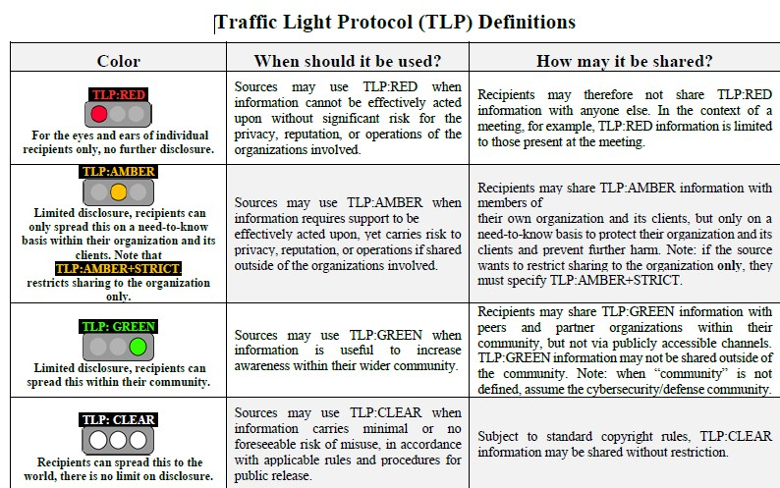

///END OF REPORT///

Umar Farouk Abdulmutallab—known colloquially as the “underwear bomber”—is the attempted suicide bomber from Nigeria who targeted a Detroit-bound airliner on Christmas Day, 2009. https://www.counterextremism.com/extremists/umar-farouk-abdulmutallab

