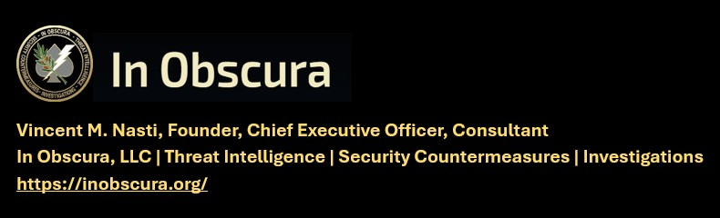

(TLP-C) ALL CHRISTIANS MUST DIE, 18 JUL 2026
KNOW THE TARGET – WATCH THE TARGET – LOOK DEEPER -EXPECT THE UNEXPECTED
Matthew 11:12 "And from the days of John the Baptist until now the kingdom of heaven suffereth violence, and the violent take it by force."
IN OBSCURA THEAT LEVEL – IMMINENT
--------------------------------------------------------------------------------------------------
CAVEAT: THIS INTELLIGENCE PRODUCT RELIES ON OPEN-SOURCE MEDIA OR GOVERNMENT RELEASED UNCLASIFIED INFORMATION. RECOMMENDED ACTIONS ARE INCLUDED FOR CLIENTS FOR INFORMATION AND ACTIONS DEEMED APPROPRIATE.
--------------------------------------------------------------------------------------------------
IN OBSCURA COMMENT
Al Naba, (English: The Great News; reality of the Day of Judgment, resurrection after death, and the rewards for the righteous and punishment for the disbelievers). I’ve chosen with his notice and approval to publish select Daneille’s NGO intelligence products. In this sharing, I will be consistent with In Obscura Mission and Vision, Intelligence Indications and Warnings and how this applies to the security of the flock.

It is imperative for the Watchmen to know and understand the target (the target of church security professionals), their TTTP and domestic United States operational and intelligence collection against Christians, Clergy, Congregations, Churches and associated properties and organizations, many of which have already been attacked. This includes foreign deployed US Christian Missionaries whom in other In Obscura products are in my current analysis not properly briefed on the travel and ground kinetic threat by the proponent domination headquarters prior to deployment. Remember much of this war is controlled as foreign nation state proxy group forces.
In continuing, the expansion across Africa has been made possible by increasingly sophisticated weapons and tactics, including the use of drones for attacks, reconnaissance and propaganda, according to the Armed Conflict Location and Event Data (Acled). Some 86 per cent of all Islamic State activity in early 2026 took place in Africa, as the continent became the group’s main focus, according to Acled, which monitors war and political violence.

Taken together, Africa’s jihadist groups “represent an ever-growing, expanding threat,” the new report said. “A unique combination of considerable military strength, extensive territorial control, and embeddedness within global trade and ideological networks has turned once-local insurgents into global actors capable of challenging African governments and testing Western interests and intelligence.”

The new analysis comes after al-Qaeda-affiliated fighters in Mali, Jama’at Nusrat al-Islam wal-Muslimin (JNIM), allied with Tuareg separatists to humiliate the country’s Moscow-backed junta in late April.

Jihadist groups in Africa’s Sahel have expanded their operations dramatically, doubling the geographic scope of attacks and operating across an area exceeding one million square kilometres—twice Spain’s size. An AFP analysis of Armed Conflict Location & Event Data Project (ACLED) records shows nearly 77,000 deaths since 2019, with violence persisting into November 2025 amid ongoing blockades and turf wars.

Also, a United Nations finding in 2024, explains that “In just a matter of years, Africa has become the ‘global epicentre of terrorism’, with groups such as Da’esh, Al-Qaida and their affiliates exploiting local conflicts and fragilities to serve their own ends, the UN Secretary-General said on Wednesday, calling for violent extremism to be rooted out.”

Surge in Violence
Factions linked to Al-Qaeda, especially the Group for the Support of Islam and Muslims (JNIM), and the Islamic State (IS) now target nearly all of Mali and Burkina Faso, extending from western Niger and Nigeria to the Senegal border.
A secondary violence hub thrives near Lake Chad in eastern Nigeria, where Boko Haram and IS West Africa Province (ISWAP) maintain strongholds.
This assessment draws from AFP’s review of six years of ACLED data, an independent monitor tracking global conflicts. Attacks surged from 1,900 in 2019—mostly along the Mali-Burkina Faso border—to over 5,500 in 2024. Through October 10, 2025, another 3,800 incidents occurred, pushing the six-year total to 28,715.

As always, I caution against passivity, pacification and compliance of church security which departs from biblical predications and a silent refusal of clergy to establish a proper protection posture. We must be proactive, void of pattern recognition, innovative and in detection of suspicious and anomalous activities and the ability to detect, identify, exploit and neutralize threats to our flock in coordination with government police and security elements. LEFT OF BOOM. Many bolded text below are mine for emphasis…

###

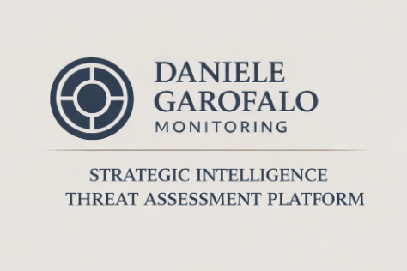
Intelligence Brief | Islamic State — al-Naba Weekly Analysis
Issue No. 556 | Threat and Operational Assessment
Daniele Garofalo Jul 19, 2026 https://www.danielegarofalomonitoring.com/p/intelligence-brief-islamic-state-8a6

Executive Intelligence Summary
The Islamic State’s weekly magazine, al-Naba, remains a critical source for assessing the organisation’s operational tempo, geographic dispersion, and signalling posture across theatres. The weekly newsletter reached number 556 last Thursday.

The weekly newsletter’s increased focus on West Africa aims to underscore its critical role, encouraging the audience to recognize the region’s strategic significance and feel motivated to prioritize region-specific countermeasures.
Time horizon: 30–90 days
The confidence level is assessed as Medium, reflecting the reliability of sources and verification methods used, which informs the assessment’s credibility and helps decision-makers understand its limitations.

Source Basis & Methodology
This assessment is based on a direct analysis of primary propaganda material from al-Naba Issue No. 556, supplemented by OSINT, IMINT, and SOCMINT, which collectively provide a comprehensive and corroborated view of current operations, supporting informed decision-making.
The analysis integrates:
- OSINT
- IMINT
- SOCMINT
to contextualise reported attacks and assess credibility and operational relevance.

Limitations & Analytical Notes
- Reported casualty and damage figures may be exaggerated.
- Some attacks are presented without independent verification.
- The claims published in al-Naba are generally reliable regarding the occurrence of attacks; however, casualty and damage figures may be inflated for propaganda purposes, a fact that should be considered when assessing operational impact.

Claims published in al-Naba are assessed as generally reliable regarding the occurrence of attacks, while casualty figures and material damage are likely to be inflated for propaganda purposes. Analytical judgments in this assessment prioritise event verification and pattern analysis over reported impact.

Historically, Islamic State attack claims in al-Naba have mainly proven accurate in terms of occurrence, with inflation primarily affecting reported impact rather than event existence.

📌 Inside this Assessment
- Activity and Operations Analysis
- Number, Targets, and Areas of Attacks
- Charts and Statistics
- Strategic Impact and Operational Implications
- Implications for Policy and Counterterrorism: Counterterrorism efforts should prioritise intelligence, rural security, and stabilisation, empowering the audience to take targeted action.

Issue 556, eight pages long, covers the week of 24 Muharram to 1 Safar 1448, from 9 to 15 July 2026.

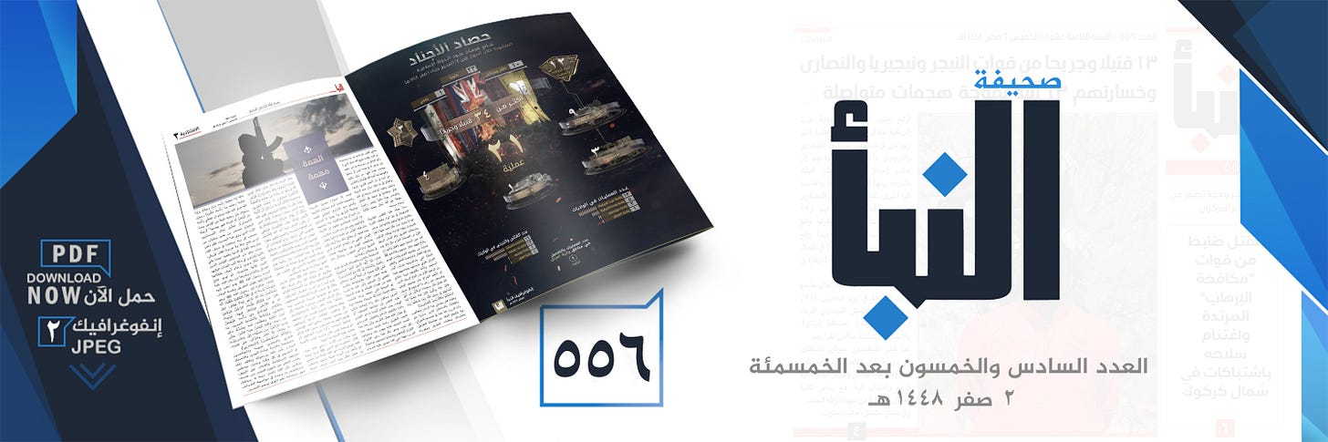
Al-Naba generally includes most of the statements and photos published daily over the past week on its official channels, although often with new elements or additional details, both written and photographic. However, al-Naba won’t include unpublished statements or messages.

The main infographic summarises the areas affected by military operations this week, including:

Nigeria, Niger, Mozambique, Iraq, and the Democratic Republic of Congo.
IS claims to have conducted 21 operations in all the mentioned areas and to have caused 34 deaths and injuries.

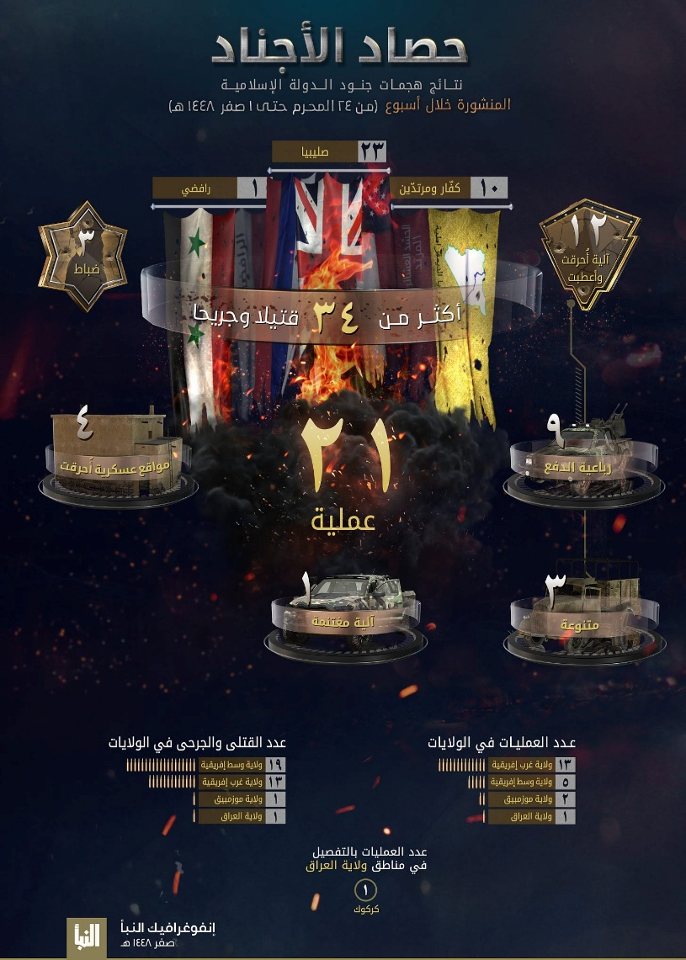
On the fourth page, the weekly magazine goes into detail about the types of attacks, operations, and targets of Islamic State fighters, who follow two main strategies: “war of attrition” and “economic warfare”, as well as other methods aimed at targeting Christians and Shiites. Since 20 March 2025, the Islamic State has embarked on a new military campaign, particularly in Africa (in the areas of Nigeria, Niger, Cameroon, and Mozambique), called “Burning Camps”. Below is a detailed account of the attacks by province/area:

1) West Africa Province: The weekly al-Naba reports 13 attacks carried out by ISWAP militants: 12 attacks against checkpoints, convoys, and camps of the Nigerian army and pro-government militias in the states of Borno and Adamawa, Nigeria; 1 attack against a Nigerien army checkpoint in the Diffa region of Niger.

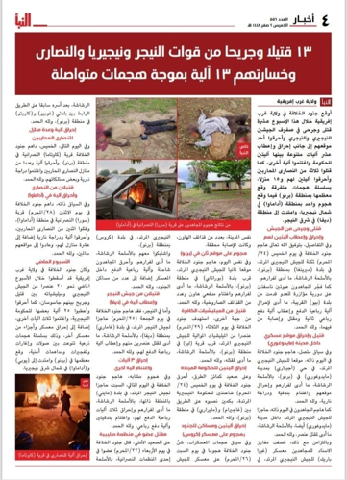
2) Central Africa Province: The weekly al-Naba reports that ISCAP militants carried out 5 attacks against Congolese army patrols and barracks in North Kivu Province, in the Democratic Republic of the Congo.

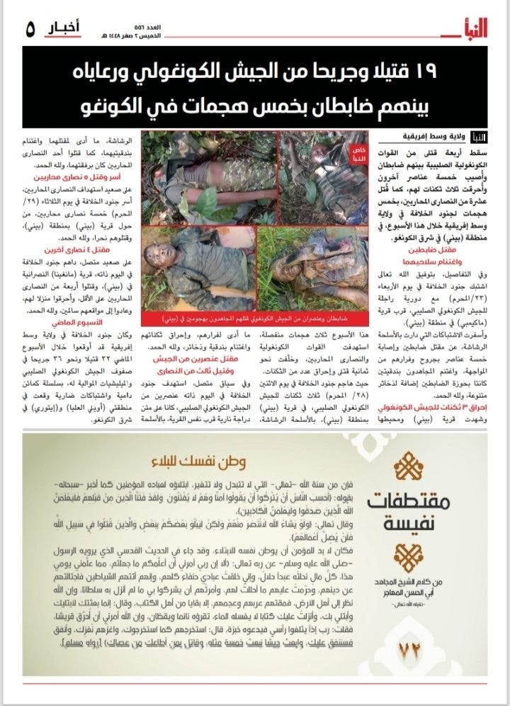

3) Province of Iraq: The weekly al-Naba reports that Iraqi militants carried out 1 attack against a patrol of the Iraqi counterterrorism forces, killing one officer, in the Kirkuk Governorate, Iraq.

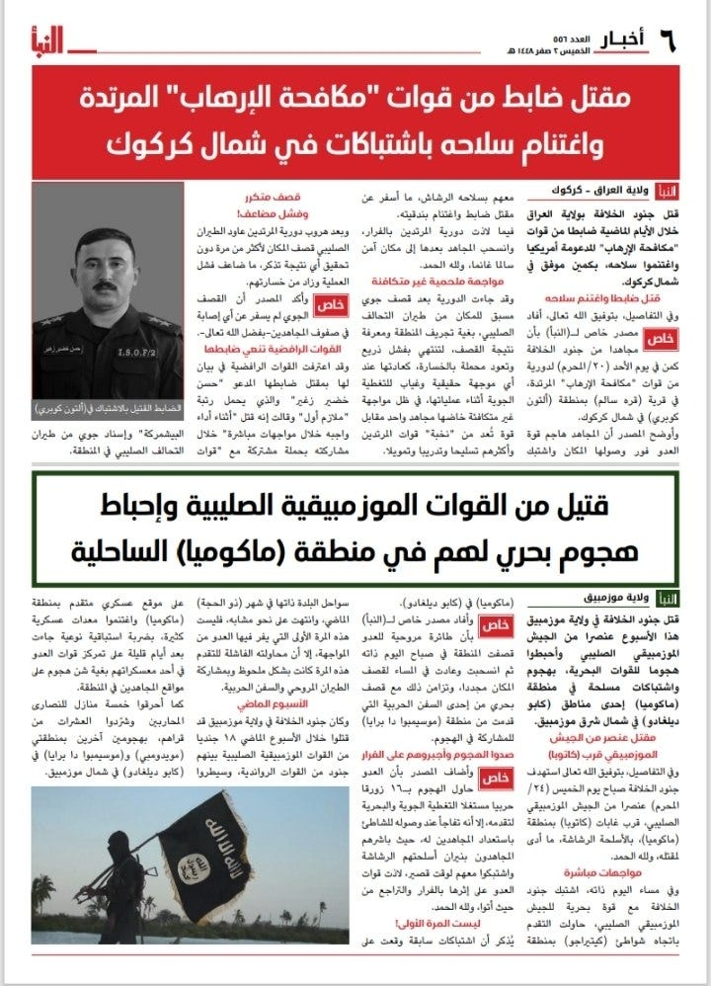

4) Mozambique Province: The weekly al-Naba reports on 2 operations carried out by ISM militants against the Mozambican army in the Macomia district of Cabo Delgado province, Mozambique.

CONCLUSION 1 — Strategic Impact and Operational Implications
Issue 556 reinforces the assessment that the Islamic State remains operationally resilient despite the absence of any significant strategic breakthrough. The reduction to 21 claimed attacks and 34 reported casualties indicates a week characterized by lower operational intensity, yet the geographical distribution of activity confirms that the organisation continues to preserve simultaneous pressure across multiple theatres. The operational tempo remains sufficient to sustain propaganda credibility, demonstrate organisational cohesion, and project the image of an active global insurgency, inspiring confidence in ongoing efforts.

Nigeria once again represented the principal operational centre of gravity. Thirteen of the twenty-one claimed operations were conducted by ISWAP, confirming that the Lake Chad Basin continues to function as the organisation’s most important military theatre. The concentration of attacks against Nigerian military checkpoints, convoys, camps, and pro-government militias reflects a sustained strategy of attrition designed to impose continuous operational costs on security forces rather than achieve immediate territorial gains.

The recurring targeting of Adamawa alongside Borno also suggests continued efforts to preserve tactical flexibility across the wider northeastern operational environment.
The Democratic Republic of the Congo remained the second most active theatre. Although ISCAP reported only five attacks, its continued focus on Congolese military patrols and barracks in North Kivu demonstrates the group’s ability to maintain persistent pressure despite repeated military operations against its infrastructure. The organisation continues to exploit difficult terrain, fragmented security governance, and limited state presence to preserve operational freedom and sustain long-term insurgent activity.

Mozambique remained comparatively less active, with two reported attacks against Mozambican security forces in Cabo Delgado. Nevertheless, the persistence of attacks in Macomia confirms that Islamic State Mozambique retains the capability to survive counterinsurgency pressure and preserve an operational foothold within its traditional areas of influence. Even limited operational activity helps maintain organisational visibility and local recruitment potential.

The inclusion of Iraq highlights the continued survival of the organisation’s historical core insurgency. Although reduced to a single targeted attack against Iraqi Counter Terrorism Service personnel in Kirkuk, the operation demonstrates that Islamic State retains a residual capability for selective attacks against high-value security targets. Rather than representing renewed expansion, these attacks illustrate the persistence of clandestine insurgent networks that can exploit local vulnerabilities.

The single operation claimed in Niger further illustrates the interconnected nature of Islamic State activity across the broader Sahelian environment. Although operationally limited, continued attacks against Nigerien military positions contribute to maintaining pressure across regional security forces and reinforce the narrative of a geographically expanding insurgency extending beyond Nigeria.

From a strategic perspective, Issue 556 demonstrates that Islamic State continues to privilege operational persistence over spectacular attacks. The organisation appears primarily focused on preserving experienced cadres, sustaining local insurgencies, maintaining propaganda continuity, and gradually eroding state capacity through cumulative military pressure. This model remains particularly effective across African theatres, where structural weaknesses in governance continue to provide favourable operating conditions.

CONCLUSION 2 — Implications for Policy and Counterterrorism
The current operational pattern reinforces the need for counterterrorism strategies that prioritise the long-term degradation of insurgent ecosystems over short-term tactical success. Weekly fluctuations in attack numbers should not be interpreted as evidence of organisational decline. Instead, Islamic State continues to demonstrate strategic patience, preserving its operational networks while adapting the tempo of military activity according to local conditions and available opportunities.

Nigeria should remain the highest operational priority. ISWAP continues to account for the largest proportion of Islamic State’s global activity, demonstrating sustained capacity to challenge military mobility, attack security infrastructure, and undermine local governance. Counterterrorism efforts should increasingly focus on disrupting logistical corridors, intelligence collection networks, recruitment mechanisms, and financial sustainment across the Lake Chad Basin, rather than concentrating exclusively on kinetic operations.

The Democratic Republic of the Congo remains a critical theatre requiring sustained international attention. Persistent attacks against Congolese military positions indicate that ISCAP continues to exploit institutional weaknesses, limited territorial control, and insufficient security coordination. Improving military mobility, intelligence fusion, border surveillance, and civilian protection mechanisms remains essential to limiting the organisation’s operational freedom.

Mozambique continues to require a sustained preventive approach despite the relatively low weekly activity. Islamic State Mozambique has repeatedly demonstrated an ability to recover following periods of reduced operational visibility. Maintaining continuous military pressure while strengthening local governance, maritime security, and civilian resilience remains essential to preventing renewed operational expansion in Cabo Delgado.

The continued appearance of attacks in Iraq illustrates that residual Islamic State networks remain capable of selective operations against security forces. Maintaining persistent intelligence collection, human source penetration, and counterterrorism surveillance remains necessary to prevent dormant networks from regenerating into more capable insurgent structures.

Across all theatres, the evidence continues to indicate that Africa remains the organisation’s primary strategic priority. The overwhelming concentration of operational claims originating from Nigeria, the Democratic Republic of the Congo, Mozambique, Niger, and neighbouring regions reflects a deliberate redistribution of organisational effort toward environments characterised by fragile governance, limited state presence, and protracted security crises. This trend has become one of the defining characteristics of Islamic State’s global strategy throughout 2026.
For NATO members, European governments, United Nations agencies, and partner intelligence services, the principal challenge is no longer preventing the emergence of new Islamic State provinces, but limiting the long-term consolidation of existing African insurgent ecosystems. These theatres increasingly serve as reservoirs of operational experience, ideological legitimacy, recruitment capacity, and organisational resilience, with implications that extend well beyond their immediate regional environments.

Continuous intelligence sharing, support to partner security forces, coordinated regional stabilisation initiatives, and sustained monitoring of transnational facilitation networks remain essential to preventing local insurgencies from evolving into broader international security threats.

🔒 Executive Intelligence Cycle
This assessment is part of a broader analytical cycle.
Founding subscribers receive the Executive Intelligence Briefing, which integrates all threat assessments, cognitive domain analysis, and a rolling 30–90-day forecast into a single monthly strategic synthesis.

© Daniele Garofalo Monitoring - All rights reserved.
Daniele Garofalo is an independent researcher and analyst specialising in jihadist terrorism, Islamist insurgencies, and armed non-state actors.
His work focuses on continuous intelligence monitoring, threat assessment, and analysis of propaganda and cognitive/information dynamics, with an emphasis on decision-oriented outputs, early warning, and strategic trend evaluation.
ISSN (International Standard Serial Number): 3103-3520
NATO NCAGE: AX664 (NATO Commercial and Governmental Entity)
UNITED NATIONS Global Marketplace ID: 1210727
ORCID Code: 0009-0006-5289-2874



///END///
====================================================================
REQUEST WRITTEN PERMISSION, EMAIL, PRIOR TO DISSEMINATING ANY IN OBSCURA PRODUCTS OR INFORMATION.
TRAFFIC LIGHT PROTOCOL REQUIREMENTS FOR DISSEMINATION
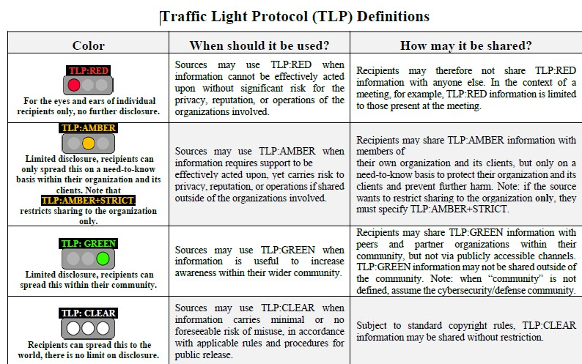

///END OF REPORT///

African Jihadists “Unquestionably Ascendant” as US Cuts Africa Force by 75 Percent, CSIS Warns, SOFX, Staff Writer, June 5, 2026 https://www.sofx.com/african-jihadists-unquestionably-ascendant-as-us-cuts-africa-force-by-75-percent-csis-warns/, FIRST REPORTED BY IN OBSCURA HERE (TLP-C) TLP-C JIHAD GROUPS AFRICAN EXPANSION (ACLED) 18 MAY 2026 https://inobscura.org/wp-content/uploads/2026/05/TLP-C-JIHAD-GROUPS-AFRICAN-EXPANSION.pdf
West Africa now the global centre of Islamist Jihadism, Staff Writer By Staff Writer May 27, 2026, https://nationalsecuritynews.com/2026/05/west-africa-now-the-global-centre-of-islamist-jihadism/
Jihadist activities spread across Africa’s Sahel Military Africa by Military Africa November 14, 2025in FEATURED, Intelligence, Security https://www.military.africa/2025/11/jihadist-activities-spread-across-africas-sahel/

