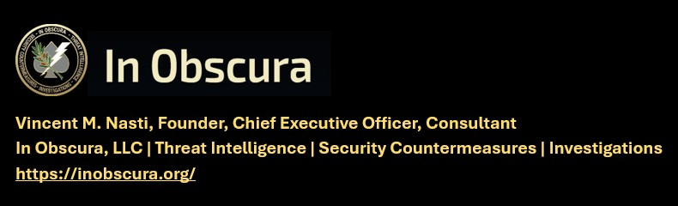

(TLP-C) SIGNFICANT ACTIVITY WEEKLY 3 AUGUST 2026
KNOW THE TARGET – WATCH THE TARGET – LOOK DEEPER -EXPECT THE UNEXPECTED
Matthew 11:12 "And from the days of John the Baptist until now the kingdom of heaven suffereth violence, and the violent take it by force."
IN OBSCURA THEAT LEVEL – IMMINENT
---------------------------------------------------------------------------------------------------------------
CAVEAT: THIS INTELLIGENCE PRODUCT RELIES ON OPEN-SOURCE MEDIA OR GOVERNMENT RELEASED UNCLASIFIED INFORMATION. RECOMMENDED ACTIONS ARE INCLUDED FOR CLIENTS FOR INFORMATION AND ACTIONS DEEMED APPROPRIATE.
---------------------------------------------------------------------------------------------------------------
KEVIN RIDEOUT (ABDUCTED) October 2025
This will be a continual weekly reminder
CONTINUAL FERVENT PRAYER REQUEST
SIM International, Pilot, Missionary, Niamey, Niger –
4 AUGUST 2026: Nothing Significant to Report (NSTR)

In Obscura News Report, 25 Oct 25
https://inobscura.org/wp-content/uploads/2025/10/TLP-CLEAR-INOBSCURA-NEWS-FOR-25-OCT-2025.pdf Source: Niger | Kidnapping of American Pilot in Niamey: Renewed

###
Religious leaders unite after gun pulled during argument at Albuquerque Catholic church by: Bianca Hoop, KRQE News, Posted: Jul 29, 2026 / 09:48 PM MDT, Updated: Jul 30, 2026 / 09:59 AM MDT,
https://www.krqe.com/news/crime/religious-leaders-unite-after-gun-pulled-during-argument-at-albuquerque-catholic-church/
TV NEWS VIDEO
https://www.msn.com/en-us/news/other/man-charged-after-gun-incident-at-albuquerque-church-following-mosque-dispute/vi-AA299rGD?ocid=BingNewsVerp#details

ALBUQUERQUE, N.M. (KRQE) – A fight between a woman and a Catholic church that started on social media escalated to a gun being pulled at the parish. It had Albuquerque religious leaders speaking out Wednesday night to support the church.
https://www.krqe.com/news/crime/religious-leaders-unite-after-gun-pulled-during-argument-at-albuquerque-catholic-church/

Father Vincent Chavez of St. Therese of the Infant Jesus Catholic Church said he publicly supported an Islamic Mosque to be built in their North Valley neighborhood. He then started receiving messages of hate online from a woman. So, he called her out personally on this church marquee, which last week said “Racism Grave Sin Against God” with her name below it. That led to a gun confrontation.

“You can post all you want; you have freedom of speech on your Facebook to trash me, and I’m experiencing hate and then gun,” said Chavez. “We’re gonna be addressing this issue in our city, in our community of bringing our humanity to peaceful dialogue, dialogue,” said Chavez. Father Chavez shared cell phone video where you can see the man with a gun in his hand.

According to police, he is 72-year-old David Romero, the woman’s boyfriend. He came into the church parking lot during a screaming match between his girlfriend and a church groundskeeper over the sign. Police said the worker pepper sprayed him and Romero pulled out a gun.

Tucson man accused of trying to burn down church
Antonio Bernard Johnson was arrested on charges or arson and criminal damage after allegedly trying to burn down a church near Park Avenue and 29th Street.
By Michael Cooper Published: Jul. 31, 2026 at 6:32 PM EDT https://www.kold.com/2026/07/31/tucson-man-accused-trying-burn-down-church/

TUCSON, Ariz. (13 News) - A Tucson man has been accused of trying to burn down the church he attended. Antonio Bernard Johnson was arrested Tuesday, July 28, on charges of arson and criminal damage. As of Friday, July 31, he was being held on a $20,000 bond.

According to the interim complaint, Johnson was caught on video setting fire to the front door of the Church of the Street, which is located near Park Avenue and 29th Street. The Tucson Police Department confirmed no one was in the church at the time, and there were no injuries. The church suffered more than $1,000 in damages. Crews from the Tucson Fire Department put out a large fire at the front door of the church, and a smaller fire at the back door.

Witness statements led investigators to Johnson, who was found near 24th and Tyndall.
Johnson claimed he was not involved in the fire, but he had singed leg and arm hair. When asked about it, he claimed he did it with a lighter. He admitted he frequents the church daily, and knows it hosts services several times per day.

Bride-to-be accused of setting fire to Utah church building while preparing for wedding
by Aubree B. Jennings, KUTV, Tue, July 28, 2026 at 8:45 AM Updated Tue, July 28, 2026 at 12:46 PM, https://abc3340.com/news/nation-world/bride-to-be-accused-of-setting-fire-to-utah-church-building-while-preparing-for-wedding

The groom also told investigators they had gone to Ace Hardware earlier in the day to buy some hooks for the wedding. After reviewing footage, officials said Moreno stole two to three lighters from the store. Officials said the groom was not nearby when she allegedly grabbed the lighters. In an interview, Moreno allegedly admitted to stealing from the store but would not say what she took.

"It is believed that Lenita (Tessa) started a fire within a church building while 5 others were still inside," the probable cause stated. "Lenita did not obtain a marriage license for her own wedding that was to occur the following day after the fire but had lied stating she had." The fire caused more than $108,000 in damages. Moreno was booked in the Davis County Jail facing multiple charges, including first-degree aggravated arson, misdemeanor retail theft and providing false information to a peace officer.

Five youths nabbed after shooting gel guns at church-goers in St. Dom’s parking lot, police say, By Ed Runyan. Vindy.com, August 1, 2026, https://www.vindy.com/news/local-news/2026/08/five-youths-nabbed-after-shooting-gel-guns-at-church-goers-in-st-doms-parking-lot-police-say/

YOUNGSTOWN -- One juvenile was charged with misdemeanor assault and four others were charged with misdemeanor menacing after a July 11 incident in a parking lot at St. Dominic Church on Southern Boulevard. There the juveniles allegedly shot Orbeez gel guns at people walking to their cars after Mass. One of the victims was struck multiple times at close range and sustained significant bruising to his face, according to a Youngstown Police Department news release. The victim is an older man, according to police.

The incident began with five masked juveniles carrying gel guns walking into the church parking lot and asking people for money as they walked to their cars, the release states. "When requests were ignored, one of the juveniles (age 13 from East Lucius Avenue) started to shoot his Orbeez gun at multiple people," the release states. "One person was struck as he drove his vehicle out of the parking lot, and another person was struck multiple times from close range."

Terrorist Kidnapping of Pastor’s Wife and Children Highlights Nigerian Tragedy Overlooked in West | A Netherlands-based watchdog group says almost 3,500 Christians were killed for their faith in Nigeria during the 12 months ending in September 2025. HOLLIE McKAY, New York Sun, Published: Aug 1, 2026, 04:00 AM ET Updated:Aug 1, 2026, 06:30 AM ET, https://www.nysun.com/article/terrorist-kidnapping-of-pastors-wife-and-children-highlights-nigerian-tragedy-overlooked-in-west

A commercial vehicle’s trip to the town of Damasak in Nigeria’s Borno State was interrupted on Saturday, July 18. Gunmen believed to belong to Boko Haram or its ISIS-aligned offshoot, the Islamic State West Africa Province, stopped the vehicle near Kareto village and ordered out four passengers: the wife of a Christian pastor and her three young children.

The driver and remaining riders were allowed to continue on. The mother and her children were marched into the bush, and two weeks later, their location is still unknown. The woman is the wife of the Reverent Moses G. Guguma, who leads a congregation of the Church of Christ in Nations (COCIN) in Damasak. According to community sources cited by Legit.ng, she had just been discharged from a hospital at Maiduguri following a lengthy illness when the family set out on the 98-mile trip north.

A resident who spoke to reporters on condition of anonymity said the family was deliberately singled out because of its faith, a detail consistent with a wave of attacks that has made northeastern Nigeria one of the deadliest places on earth to practice Christianity.

Sheriff’s office: Kingsport man arrested after threatening churches
by: Slater Teague, Posted: Jul 25, 2026 / 02:59 PM EDT, Updated: Jul 25, 2026 / 02:59 PM EDT, https://www.wate.com/news/local-news/sheriffs-office-kingsport-man-arrested-after-threatening-churches/

KINGSPORT, Tenn. (WJHL) — A man was arrested for making threats to two churches, according to the Sullivan County Sheriff’s Office (SCSO). The sheriff’s office said it was made aware of threats made by Robert Lewis Wilson, 39, of Kingsport, on Thursday afternoon.

Investigators determined that Wilson had allegedly called a local church and left a threatening voicemail that caused church staff members to fear for their safety. Popular Market Square spot Myrtle’s Chicken and Beer shuts down
Detectives later reportedly learned that Wilson had called a second church and left another voicemail that prompted staff members to fear for their safety.

In the second voicemail, Wilson referenced the threats he made in the first phone call, according to the sheriff’s office. “In both instances, Wilson’s threats were not directed at anyone specific; however, his statements caused staff members at both churches to fear that serious bodily injury could occur,” the SCSO said in a release. Wilson was a former member of one of the churches and had been trespassed from the location, according to the sheriff’s office.

Virginia university report finds officials did not disclose student’s terror conviction
ODU says Virginia law limited criminal history screening, and no federal agency notified campus officials, By Bonny Chu Fox News, Published July 30, 2026 4:01pm EDT | Updated July 30, 2026 5:00pm EDT https://www.foxnews.com/us/virginia-university-report-finds-officials-did-not-disclose-students-terror-conviction

Montgomery County rabbi opposes gun buffer around places of worship
by Alan Henney &Madison Forsey; Sun, August 2, 2026 at 9:12 PM, Updated Mon, August 3, 2026 at 9:45 AM https://wjla.com/news/local/montgomery-county-bill-23-26-menashe-shapiro-rabbi-synagogue-jewish-community-houses-of-worship-firearms-gun-restrictions-second-amendment-religious-freedom-constitutional-rights-volunteer-security-hired-security-montgomery-county-council-maryland-suprem

NOTE COURT DOCUMENTS EMBEDDED IN THIS ARTICLE

Montgomery County rabbi is challenging a county law restricting firearms near places of worship, arguing the measure violates both his constitutional rights and his congregation's ability to provide for its own security. (7News)

ROCKVILLE, Md. (7News) — A Montgomery County rabbi is challenging a county law restricting firearms near places of worship, arguing the measure violates both his constitutional rights and his congregation's ability to provide for its own security. Rabbi Menashe Shapiro told 7News that Bill 23-26, which prohibits people from carrying firearms within 100 yards of certain public places, including houses of worship, parks, schools and libraries, puts Jewish congregations at greater risk. At this point, what they've done is pretty dangerous," Shapiro said. Shapiro argued the measure improperly allows the county to dictate how synagogues protect themselves.


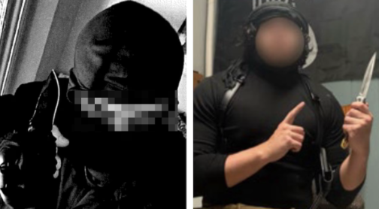
[Update] 2 N.J. Men Wanted To Fight For ISIS. Instead, They're Facing Years In Prison
Source: NJ.com
(New Jersey) Two Essex County men who prosecutors said wanted to carry out so-called Islamic State (ISIS)-inspired attacks and fantasized about killing Jewish people pleaded guilty this week to terrorism-related offenses, authorities said. Tomas-Kaan Jimenez-Guzel, 19, and Milo Sedarat, 21, both of Montclair, pleaded guilty to supporting ISIS, U.S. Attorney Robert Frazer said in a statement. Jimenez-Guzel pleaded guilty on Monday to providing material support to a designated foreign terrorist organization, while Sedarat pleaded guilty on Tuesday to concealment of material support and resources to a designated foreign terrorist organization. Read More

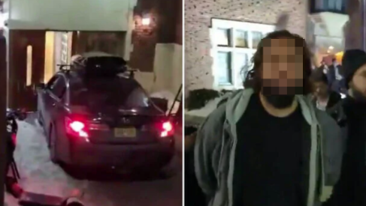
[Update] Man Who Rammed Car Into NYC's Chabad Headquarters Sentenced To Time Served Source: Times of Israel

(New York) The man who repeatedly rammed a car into the Chabad Hasidic movement’s world headquarters in New York City earlier this year was sentenced on Wednesday to time served. Dan Sohail, 36, pleaded guilty to damaging religious property in May. Sohail slammed his car into the revered religious site in January, causing widespread alarm. He was initially charged with a hate crime, but he later told investigators that he was seeking to connect with his “Jewish heritage.” An investigation found that Sohail had made outreach to Jewish groups ahead of the incident and had mental health problems. Read More

Evanston police investigating bomb threat at Evanston Hospital
Emma Richman and Jack Baker, The Daily Northwestern, July 28, 2026
https://dailynorthwestern.com/2026/07/28/top-stories/evanston-police-investigating-bomb-threat-at-evanston-hospital/

In an alert sent to hospital employees, Endeavor Health announced that there is “no immediate threat” and that the building remains open. This is a developing story and will be updated as new information becomes available.

Last updated July 28 at 10:18 p.m. The Evanston Police Department is investigating a bomb threat at Evanston Hospital, according to a Tuesday evening EPD news release. No injuries were reported, and there is no ongoing threat, EPD announced in another release shortly after 9 p.m. No arrests have been made at this time, and the investigation remains ongoing, according to the EPD.

Shortly after 5:00 p.m., officers responded to the threat, establishing a “secure perimeter around the facility” while evacuating surrounding areas, the initial release stated. Access to the area was also limited. “During the response, officers located a suspicious package with wires protruding from it outside the building. The Evanston Fire Department is deploying a drone to provide an aerial assessment of the scene while minimizing risk to emergency personnel,” the first release read. “The Cook County Bomb Squad is also responding to assist with evaluating the package and securing the area.”

Shots fired outside Little Rock funeral leave churchgoers shaken, renewing calls for church security, After a funeral honoring an 18-year-old homicide victim was interrupted by gunfire, churchgoers are renewing their calls for church security. Author: Maya Ellison, Published: 6:59 PM CDT July 24, 2026, Updated: 6:59 PM CDT July 24, 2026, https://www.thv11.com/article/news/local/little-rock/little-rock-funeral-church-shooting/91-473ae9cf-bdd9-455f-94b0-61b6b3443a0f

LITTLE ROCK, Ark. — A funeral honoring an 18-year-old homicide victim was interrupted by gunfire Saturday outside a Little Rock church, sending mourners scrambling for safety. The shooting happened during funeral services for Dillian Cheeter at Fellowship Christian Church on Baseline Road. Video from the church's livestream captured the moment shots rang out, followed by screams from people inside the sanctuary.

Church Administrator Frances Pride said she immediately recognized the gunfire was coming from outside the building but understood why those inside panicked. "I could hear the gunshots, so I understood they were outside," Pride said. "The audience, though, began to panic." As people rushed for cover, Pride said her priority was reassuring everyone inside that they were safe.

"I wanted everyone to understand that the shots were outside," she said. "The chaos, I do understand the chaos, but you were safe. I wanted the people to really understand that they were safe during that time."

The Little Rock Police Department confirmed officers responded to reports of shots fired near Baseline Road and Sunset Lane, where the church is located. Pride said the church had multiple safety measures in place, including its own security team and officers from the Little Rock Police Department who were present during the service.

"We have a security team, but we also had the Little Rock Police Department here," Pride said. She added that the church has undergone training to prepare for emergencies, including possible violence during worship services.

"We have been trained in the area of church shootings, so that we could be better protected and know how to protect the congregation as well," she said. While no one inside the church was injured, Pride said the incident underscores the toll gun violence continues to take on families and communities.

"I know the community, as well as mothers and fathers, are tired of burying our youngsters," she said. "We want to see reconciliation in our communities. We want to see the love of God spread abroad in the hearts of everyone, and it makes a difference." Despite the frightening incident, Pride said the church remains committed to serving as a safe place for the community.

"We here at Fellowship Christian Church do not condone gun violence," she said. "We pray for our neighborhood and the people within our congregation constantly. We love you. You are free to come here if you have any questions or concerns." Little Rock police have arrested 20-year-old Charles McCrary in connection with Cheeter's death. McCrary is charged with capital murder. As for the gunfire outside Saturday's funeral, investigators have not announced any arrests or identified any suspects. The incident remains under investigation.

Victim ID’d after being found dead behind Frayser church, WREG TV, by: Sarai Bennett Posted: Jul 27, 2026 / 12:28 PM CDT, Updated: Jul 27, 2026 / 06:17 PM CDT
https://wreg.com/news/local/victim-idd-after-being-found-dead-behind-frayser-church/

MEMPHIS, Tenn. — A male victim who was shot to death behind a Frayser church last week has been identified by Memphis police. Officers say the victim is Devin Edwards. Eighteen-year-old Roy Bills was arrested Friday in connection with the deadly shooting. Last Monday, officers said they responded to a homicide in the 3700 block of North Watkins. A male victim was found near the Pursuit of God Church with a gunshot wound to the chest. He was pronounced dead at the scene.

ORIGINAL STORY: Body found behind church in Frayser
Homicide investigators said they found video showing a male wearing pink shorts, who was later identified as Roy Bills, walking with Edwards shortly before the shooting. The video showed Bills shoot Edwards in the back and then take an object from him, officers reported.

By Thursday, investigators identified Bills as a suspect. They obtained a search warrant for his residence in the 1700 block of Carlye Drive. While at his home, authorities said they located a black handgun under his bed and found the pink shorts and black jacket that he was wearing in the video footage. During questioning, Bills allegedly gave a statement to investigators and admitted to being the person seen on video in the pink shorts.

Detectives then said he admitted to shooting Edwards in the back and taking a handgun from him valued at $450. Bills is expected to appear in court Tuesday morning. Add as preferred source on Google

“The New Crusade”: What the San Diego Attackers’ Manifesto Reveals About Contemporary Radicalisation, Global Network on Extremism and Technology, By Muskan Sangwan 23rd July 2026 In Insights, https://gnet-research.org/2026/07/23/the-new-crusade-what-the-san-diego-attackers-manifesto-reveals-about-contemporary-radicalisation/

PARTIAL ARTICLE
On 18 May 2026, 18-year-old Caleb Vazquez and 17-year-old Cain Clark carried out a mass-casualty attack at the Islamic Center of San Diego (ICSD), the largest mosque in San Diego County. The attack left three people dead before the perpetrators ultimately took their own lives. In the aftermath, a lengthy manifesto titled The New Crusade quickly emerged online alongside other digital materials outlining the attackers’ worldview, ideological influences, grievances, and motivations.

The manifesto reflects a familiar accelerationist worldview shaped by white supremacist ideology, admiration for previous mass shooters, and longstanding conspiracy narratives such as the “Great Replacement“. Within this framework, Muslims are portrayed as symbolic representatives of demographic replacement and perceived civilisational decline, framing the mosque as a deliberate ideological target rather than an opportunistic one. The victims are consequently presented not as individuals, but as symbols within an imagined racial conflict.

At first glance, The New Crusade – jointly written by the two perpetrators in separate sections – appears to fit comfortably within a now familiar tradition of extremist writings associated with perpetrators such as Anders Breivik, Brenton Tarrant, and Payton Gendron. Like many manifestos before it, it seeks to explain, justify, and contextualise an act of mass violence. However, the document also poses different questions about how people become radicalised in today’s digital environment. Throughout the text, the authors reflect on developments that researchers have increasingly observed across contemporary extremist ecosystems.

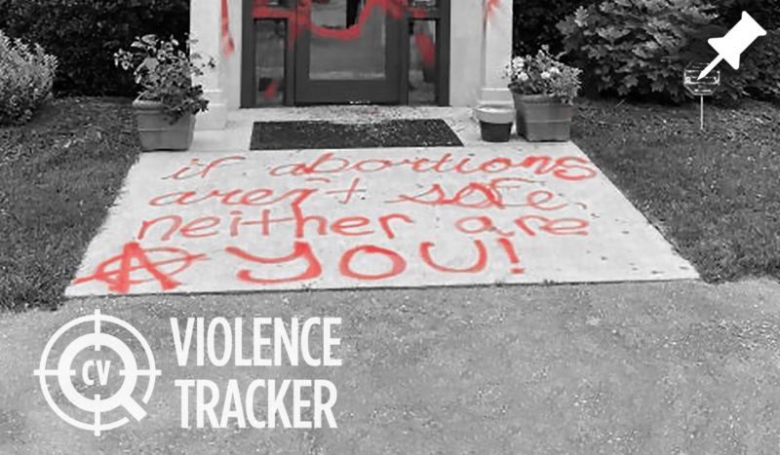
Tracking Attacks on Pregnancy Centers & Pro-Life Groups
Last Updated January 21, 2025 Attacks Since Supreme Court Leak:
https://catholicvote.org/pregnancy-center-attack-tracker/

The wave of violence began within 24 hours of the release of a leaked draft of the Supreme Court opinion which would overturn Roe v. Wade on May 2, 2022. Pregnancy centers braced for more attacks and acts of vandalism after the Supreme Court issued its final ruling overturning Roe v. Wade on June 24, 2022. The Department of Homeland Security issued a memo the same day warning that “domestic violent extremists” would exploit the decision to commit acts of violence against various targets, specifically naming Jane’s Revenge.

The attacks appear to be organized under the umbrella of two domestic terror groups — Jane’s Revenge and Ruth Sent Us — which have arisen since the Supreme Court opinion leak was published. Others appear to be connected to Antifa and anarchist groups. Many of the attacks have similar messages, including “If abortions aren’t safe, neither are you”.
After an attack in Madison, Wisconsin, Jane’s Revenge claimed credit and said they were at “war” with pro-life groups.

They demanded “the disbanding of all anti-choice establishments” and said the first attack was “only a warning”. Since then, several attacks have used the words “Jane Was Here” or “REVENGE”. The identity of the group’s leadership and the sources of its funding are unclear.

The group Ruth Sent Us has organized illegal protests outside the homes of Supreme Court justices, and has also called on its extremist supporters to storm Catholic churches during Mass. They even warned on Twitter, “We’ll be burning the Eucharist to show our disgust for the abuse Catholic Churches have condoned for centuries.” Ruth Sent Us is a shadowy group, though Influence Watch has connected the group to two Democrat activists named Vara Ramakrishnan and Sam Spiegel.
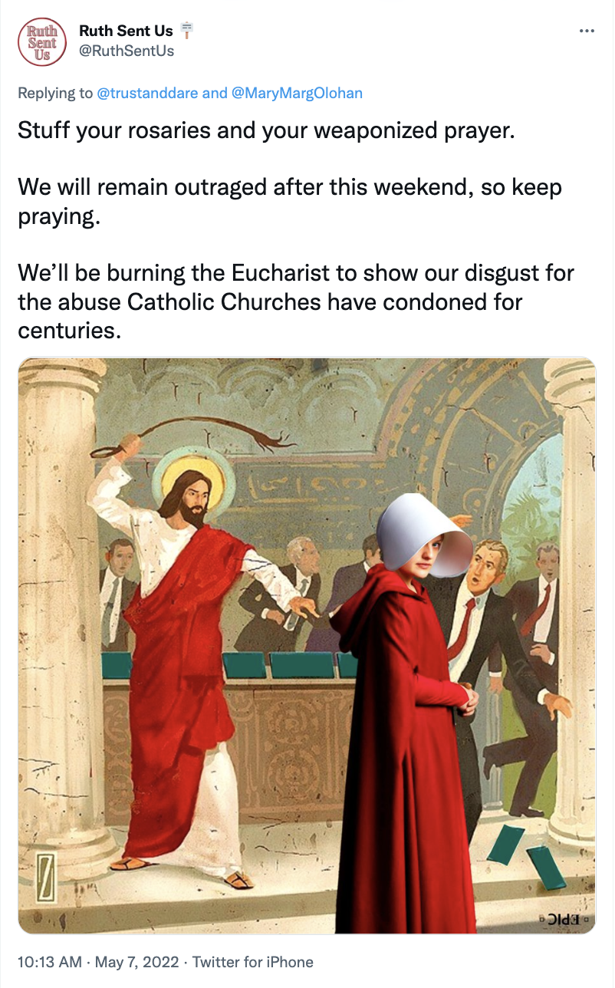

To date, there have been arrests reported in connection to only 9 of the 96 attacks. It took the FBI over six months to issue a public request for information, and even then, only nine of the attacks were included. States which have been hotbeds for these attacks include: Michigan (8), Minnesota (6), Oregon (6), California (6), New York (6), Washington (5), Texas (4), Ohio (4), Maryland (3), Virginia (3), Florida (3), Massachusetts (3), North Carolina (3), and Alaska (3).
Metro areas which have been hotbeds include Detroit (7); Minneapolis-St. Paul (5); Washington, DC (5); Portland, Oregon (5); Seattle (4); and New York City (3).
Some attacks are going unreported because pregnancy resource centers want to protect their clients.

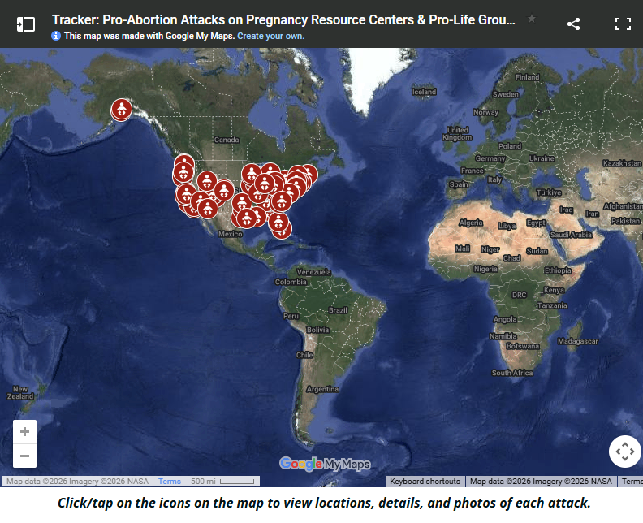

Montclair Teen Admits Providing Support to ISIS, Accepts 20-Year Plea Deal
Montclair Local, by Matt Kadosh, July 27, 2026
https://montclairlocal.news/2026/07/montclair-teen-admits-providing-support-to-isis-accepts-20-year-plea-deal/

Agents arrested Jimenez-Guzel at Newark Airport on Nov. 4, according to authorities.
Jimenez-Guzel, a student at Rowan University, admitted in court that he was preparing to fly to Turkey and then to Syria to join ISIS. He admitted that he had accelerated his plans to fly to Istanbul, Turkey, after individuals he was communicating with in Dearborn, Michigan, were charged with offenses relating to their alleged plot to carry out an armed attack on behalf of ISIS.

According to the complaint, Jimenez-Guzel and his co-conspirators discussed “practicing shooting,” and Jimenez-Guzel said he “can help with weapons training” and tactics. The complaint alleges that he sent an audio message in which he describes doing something historic.

“We need to group up near Israel, like in Jordan or something, get acquired what we need and then do something, something that’s going to leave a mark in history,” Jimenez-Guzel said, according to the complaint. “Something that’s gonna make them create a documentary on you on Netflix. Something that’s gonna make you have a Wikipedia page.”

Anarchist Group Calls For BLM-Style ‘Revolt’ At Anti-Trump ‘No Kings’ Rallies
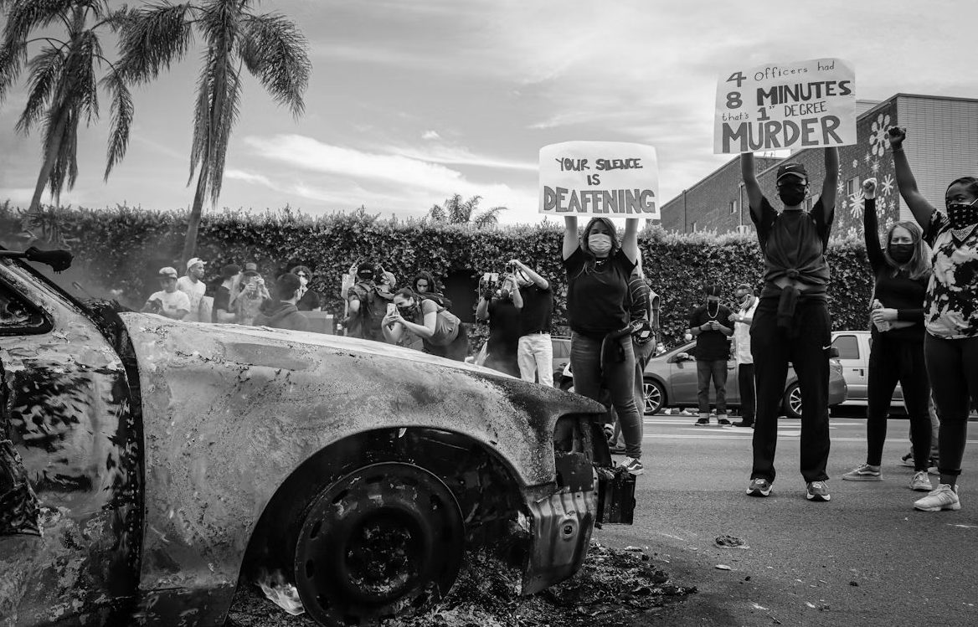
Michael Muthee/Unsplash, Hudson Crozier,October 14, 202512:33 PM ET
https://dailycallernewsfoundation.org/2025/10/14/anarchist-blm-revolt-anti-trump/\

Leftists are calling for veterans of “the George Floyd revolt” to join upcoming “No Kings” rallies against President Donald Trump on Saturday.
CrimethInc, an international anarchist group, encouraged supporters on Thursday to engage in “anti-authoritarian” uprisings similar to the 2020 Black Lives Matter riots when the nationwide anti-Trump rallies take place. The post recommended “direct action planning,” a phrase CrimethInc defines as mobilizing people to cause a public disruption even if it risks arrest.

No Kings, No Masters
“A Call for Anti-Authoritarian Blocs at the October 18 “No Kings”
“Demonstrations” https://t.co/6R4m5WqRNR
— Not CrimethInc. – Ex Workers (@Thinc_Exworkers) October 12, 2025
“To face down Donald Trump’s power grab and his terror campaign targeting ‘antifa,’ we need everyone, of all walks of life, to proclaim that opposition to fascism is both laudable and urgent,” CrimethInc’s anonymously-written post said. “We must contribute to a ferment that brings together everyone from the fiercest participants in the George Floyd revolt to the retirees that protested at Tesla outlets last spring.”
CrimethInc and No Kings did not respond to the Daily Caller News Foundation’s requests for comment. CrimethInc’s website lists mailing addresses in Olympia, Washington, and the United Kingdom.

The group linked to another of its posts from June 2020 titled “Snapshots from the Uprising,” which glorified violent Black Lives Matter demonstrations in Minneapolis and showed a local police station on fire. The anti-police riots led to 24 deaths and at least $1 billion in property damage across the country.

No Kings stresses its “commitment to nonviolent action” on its website. “We expect all participants to seek to de-escalate any potential confrontation with those who disagree with our values and to act lawfully at these events,” the site says.

Supreme Court's Gorsuch rejects Christian nationalism: 'Demonstrably false'
by RAY LEWIS | The National News DeskTue, July 28, 2026 at 12:32 PM
https://komonews.com/news/nation-world/supreme-courts-justice-neil-gorsuch-rejects-christian-nationalism-demonstrably-false-trump-administration

HUNT VALLEY, Md. (TNND) — Supreme Court Justice Neil Gorsuch, in a Friday interview focused partially on America's religious roots, rejected a right-wing view of the country as inherently Christian.

The belief, promoted by top Trump administration officials, has underpinned Christian nationalism movements that have eroded the separation of church and state envisioned by the founding fathers. Gorsuch, speaking to PBS's "Firing Line," called it a "demonstrably false" perspective.

"We were founded—a lot of our colonies—for religious pluralism, right, and the opportunity to practice your own faith in your own way. And we were never supposed to be a nation that was about one race or one religion," the justice said.

Many colonists settled in the future United States to escape religious persecution and worship freely. The founding fathers, wary of replicating the empire they were separating from, established the separation of church and state as an essential principle of their emerging government.

Two hundred and fifty years later, religion has found a home in the Trump administration, which has justified policy positions with faith-based arguments. Vance, speaking at a Turning Point USA event before Christmas, called Christianity "America's creed."

"Our country's major debates have always centered on how we could best, as a people, please God," he told the conservative crowd. "That creed—think about it—that creed motivated our understanding of natural law and rights, our sense of duty to one's neighbor, the conviction that the strong must protect the weak and the belief in individual conscience."

Charlie Kirk's widow draws crowds, protesters to Kirkland church
Hundreds lined up outside The Pursuit Church on Friday as supporters and demonstrators faced off on the sidewalk over Turning Point USA's "Make Heaven Crowded" tour.
Author: Madeline Carter Published: 11:09 PM PDT July 24, 2026, Updated: 11:09 PM PDT July 24, 2026 https://www.king5.com/article/news/local/erika-kirk-draws-crowds-protesters-kirkland-church/281-f0f94116-1b9a-4801-8440-bff8f89a895b
KIRKLAND, Wash. — A line wrapped around The Pursuit Church in Kirkland hours before Erika Kirk, widow of Turning Point USA founder Charlie Kirk, took the stage Friday night as part of the organization's "Make Heaven Crowded" tour. Organizers describe the tour as a Christian revival focused on worship, preaching and prayer. By the time the event began, a large group of protesters had also gathered on the sidewalk, stretching down 132nd Avenue Northeast.

Demonstrators said they were holding a peaceful "love over hate" protest in support of the LGBTQ+ community, immigrants and other groups they believe are targeted by Turning Point USA's messaging. The event drew heightened security, including a large police presence. Aside from some tense moments between people on opposing sides outside on the sidewalk, Friday's event remained peaceful.

Outside Erika Kirk’s Kirkland rally, protesters ask who Christianity is for
July 28, 2026 Updated Fri., July 31, 2026 at 1:33 p.m. By Micah Yip, FaVs, News Spokesman Review, https://www.spokesman.com/stories/2026/jul/28/outside-erika-kirks-kirkland-rally-protesters-ask-/

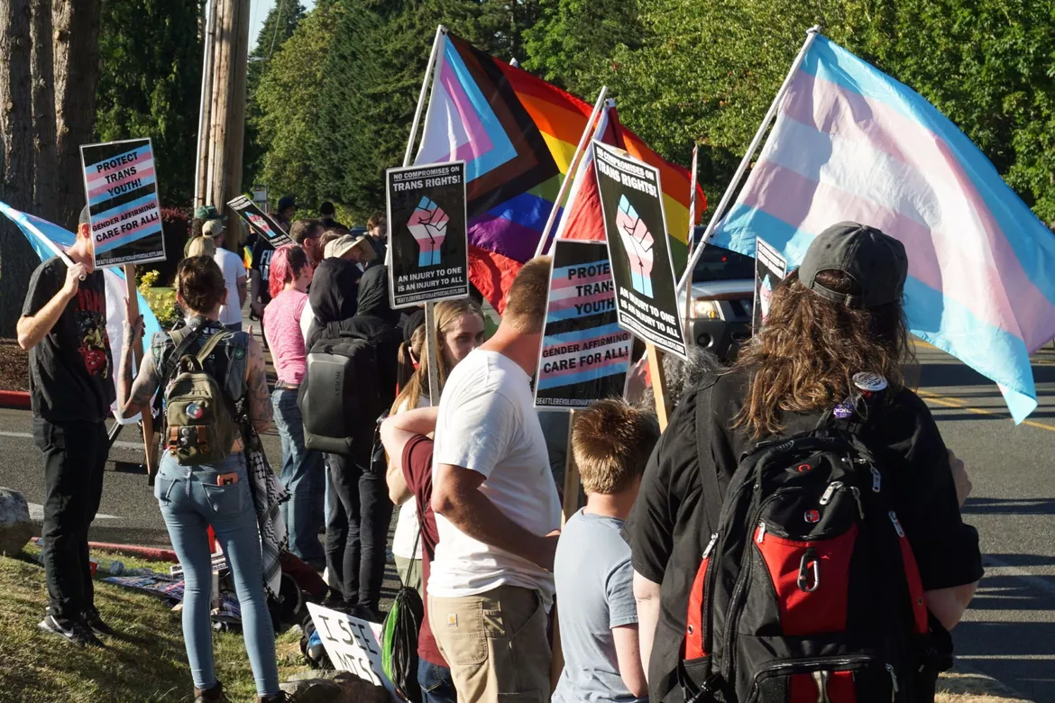
These beliefs, boldly and proudly claimed by Pursuit’s and TPUSA’s leaders, are inflammatory, and many on the left believe that’s the point. The goal, they say, is to draw leftists and activists out in droves, then circulate videos online that paint protesters as “crazy” and themselves as the rational ones.

Counter protesters purposed not to provoke
Knowing that provocation is the point, Holy Spirit Lutheran Church pastor Katy McCallum Sachse asked, in a phone call with FāVS News prior to the event: “What is the role of public protest when the organization being protested wants you to do that so they can get on the news? How do you make your voice known in a way that is meaningful, but doesn’t just draw more attention to something that is damaging?”

Instead of a protest, her church joined like-minded pastors and community leaders to participate in a private counter-event at a different church nearby. Organized by the Church Council of Greater Seattle, the event aimed to educate attendees about No Hate in WA State, a campaign to defeat two ballot measures that target transgender students.

The counter-event, held at a different church in the same general Kirkland neighborhood, wasn’t publicized. Invites were sent to progressive congregations and registrants received the location on the day of.

The low-key approach was intentional. “We want to do something that will help people understand their neighbor and will change their hearts,” McCallum Sachse said. “And we don’t need the press there to do that, but they do – they need the press to show up to put them on the news to build power, and we refuse to participate in that.”

McCallum Sachse doesn’t see TPUSA’s or Pursuit’s messaging as rooted in Scripture, saying they use Christianity to build political power.

“Any form of Christianity that not only allows you to hate your neighbor, but encourages you to hate your neighbor, is – and these are words we don’t use a lot anymore but I think they’re words that matter – it is blasphemy and idolatry and it is deeply dangerous,” McCallum Sachse said.

NOTE THE FOLLOWING:
BREAKING: Scary moment inside Pursuit Church. Friday evening, a far-left activist infiltrated Erika Kirk’s “Make Heaven Crowded Tour” in Kirkland, WA. He stood up https://www.facebook.com/ChoeShow/videos/breaking-scary-moment-inside-pursuit-church-friday-evening-a-far-left-activist-i/2488737198293209/
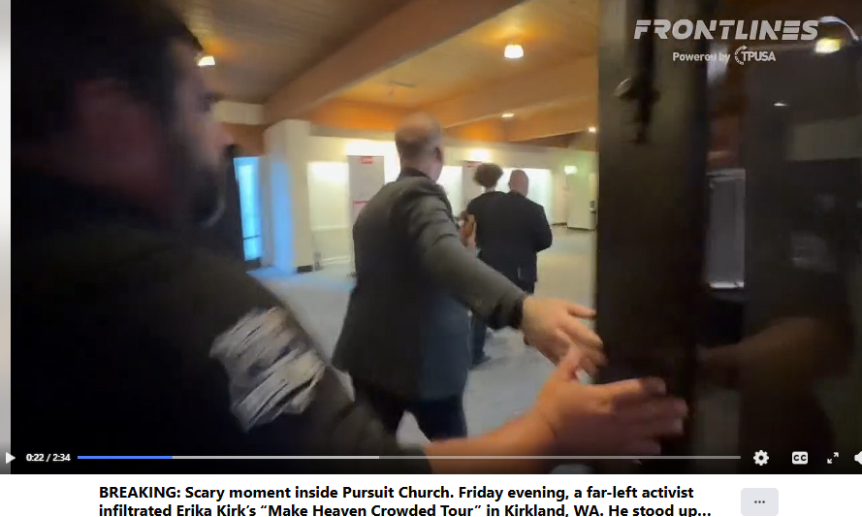
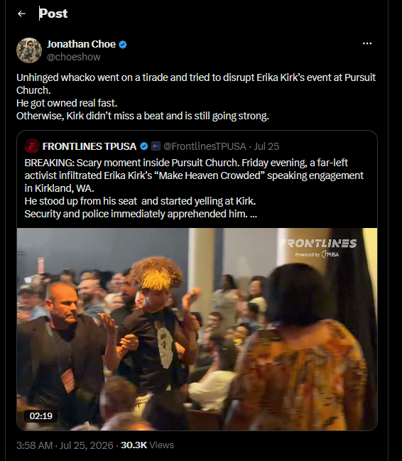

Marriott Bonvoy accused of 'genocide tourism' after 120K Christians were pushed out of their homeland By Anugrah Kumar, Christian Post Contributor Friday, July 31, 2026, https://www.christianpost.com/news/marriott-bonvoy-accused-of-genocide-tourism.html

Armenian refugees from Nagorno-Karabakh are seen in the center of the town of Goris on Sept. 30, 2023, before being evacuated to various Armenian cities. Over 100,000 people fled Nagorno-Karabakh since the breakaway region saw its decades-long fight against Azerbaijani rule end in sudden defeat.

Armenian refugees from Nagorno-Karabakh are seen in the center of the town of Goris on Sept. 30, 2023, before being evacuated to various Armenian cities. Over 100,000 people fled Nagorno-Karabakh since the breakaway region saw its decades-long fight against Azerbaijani rule end in sudden defeat.
The international hotel chain Marriott is drawing criticism as an international travel company licensed to use its brand name is selling tours through Nagorno-Karabakh, a region of the South Caucasus that Azerbaijan emptied of more than 120,000 ethnic Armenians in 2023, in what prosecutors formerly with the International Criminal Court have called a genocide.

The tour was listed on Marriott’s Bonvoy Tours & Activities platform and participants earn Marriott Bonvoy points for booking it, said the Center for Armenian Research and Analysis (CARA) in a report titled "Genocide Tourism, Occupied Artsakh and the 14-Hour Tour." It runs 14 hours out of Baku and includes a guide, transportation, entry to all sites, and hotel pickup, with guides offered in Turkish, Spanish, English, Russian and Italian.

“Permission to enter Karabakh zone” is listed among the tour’s inclusions without further comment or explanation. The webpage advertizing the tour was deactivated at some point between Thursday afternoon and Friday. When The Christian Post accessed the link on Thursday afternoon, the page was still active.

PRAISE REPORTING
Pastor who preached entire Bible in 96 hours says witch converted after cursing him: 'We wanted you to die' By Jon Brown, Christian Post Reporter Friday, July 31, 2026, https://www.christianpost.com/news/pastor-who-preached-bible-for-96-hours-says-witch-cursed-him.html
Pastor Matt Olson is physically upheld at the point of his exhaustion while preaching the sufficiency of Christ's righteousness from the book of Romans on June 2, 2026.
Pastor Matt Olson is physically upheld at the point of his exhaustion while preaching the sufficiency of Christ's righteousness from the book of Romans on June 2, 2026. | Screenshot/First Baptist Church of Sharon
The Mississippi pastor who recently preached through the entire Bible for 96 consecutive hours says a young witch in Texas who attempted to curse him as he was preaching the Gospel from Romans became a Christian after her black magic backfired.

Pastor Matthew Olson of First Baptist Church of Sharon in Jones County, Mississippi, recounted to The Christian Post some of the physical struggles and spiritual opposition he faced when he set an unofficial world record for marathon speech last month, preaching continuously through Genesis to Revelation from May 30 to June 4.

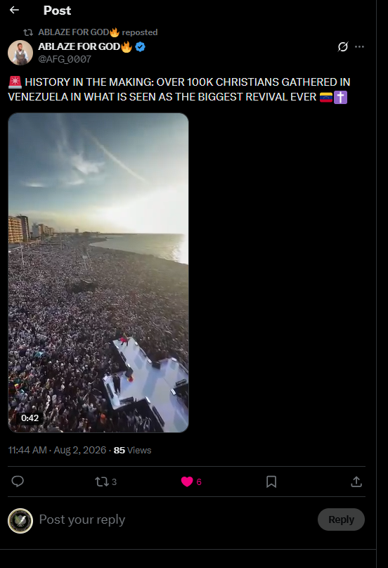
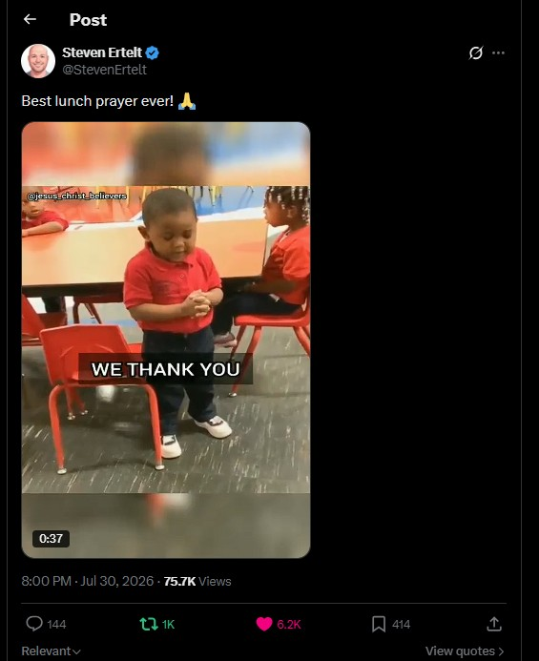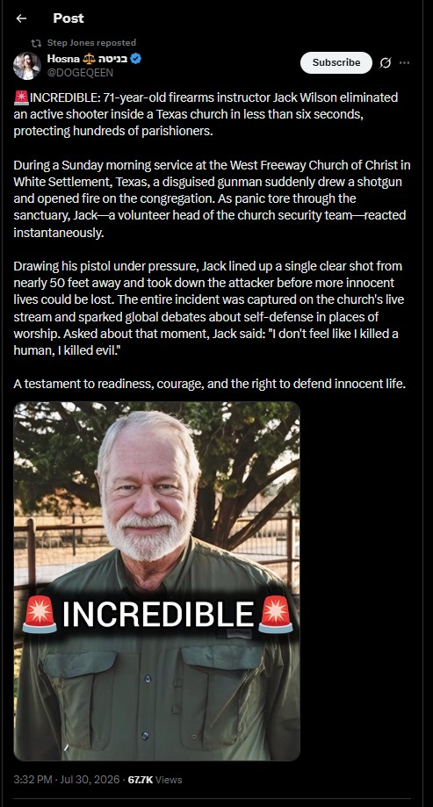
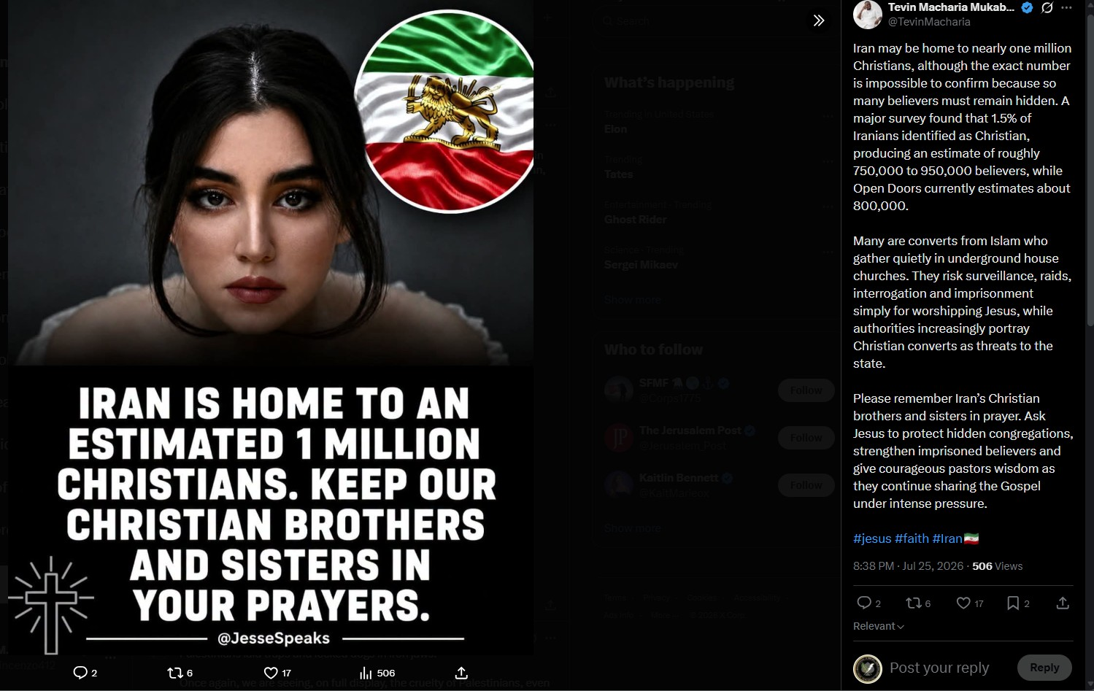

SOCIAL NETWORK INTELLIGENCE
This venue is a valuable guide to observe sentiment and atmospherics which can provide open source intelligence leads, indications, and warnings.

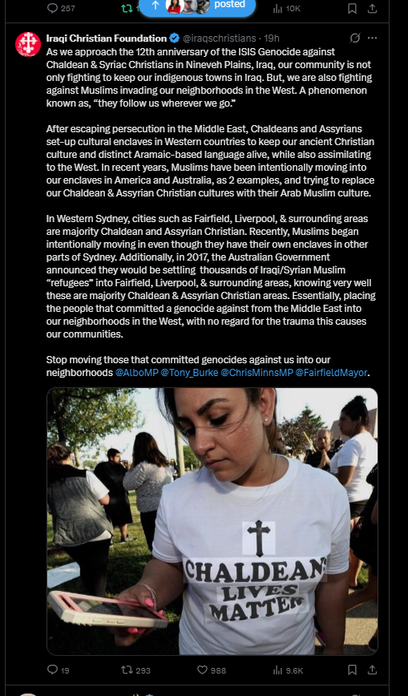

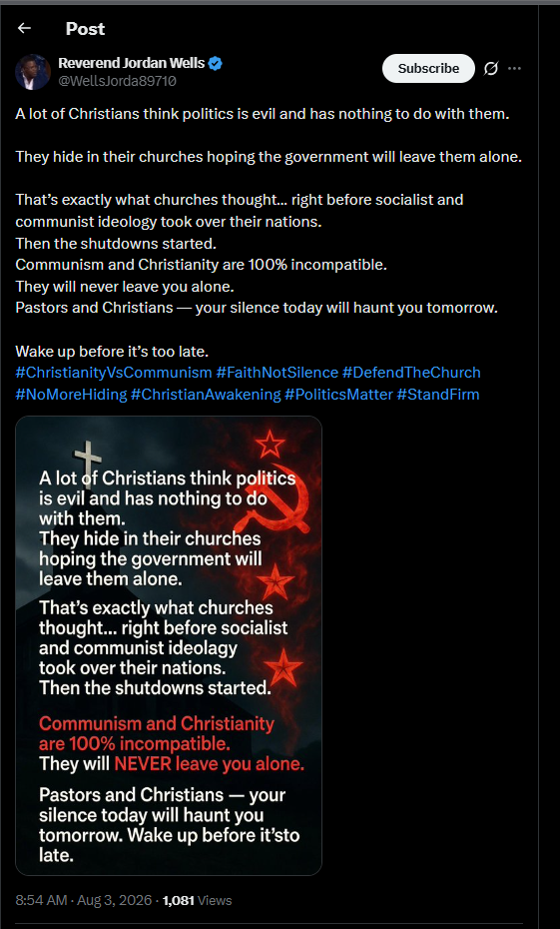



IN OBSCURA COMMENT IN THIRTY MINUTE POLICE RESPONSE TIME IN DENVER (BELOW)
Church Security professionals MUST know and understand their environment outside their inner perimeter, including active situational awareness. My model is a three-five mile radius outside the church property. This is what I term the Human Domain. That common thirty minute response time is already known and figured in by insurgents and guerilla groups and criminals during intelligence collection on YOUR church. The attack can and has come also from the mentally unstable with access to weapons and even INSIDER THREATS who become violent.

The threats, quality of life, crime, all have direct and indirect implications on the security of the flock and property. Most importantly, the response time to this incident is now the norm across the country. This is the direct result to insurgent activities such as “Defund The Police” in furtherance of direct action attacks, assault teams on church services, target surveillance and intelligence collection missions against churches. The operation tradecraft is to establish “target packets” to analyze and select for attack.

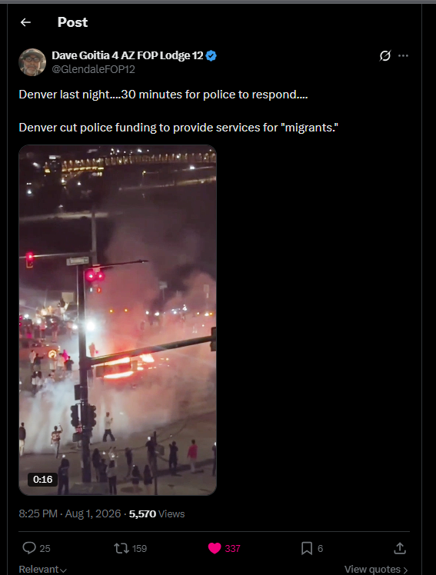
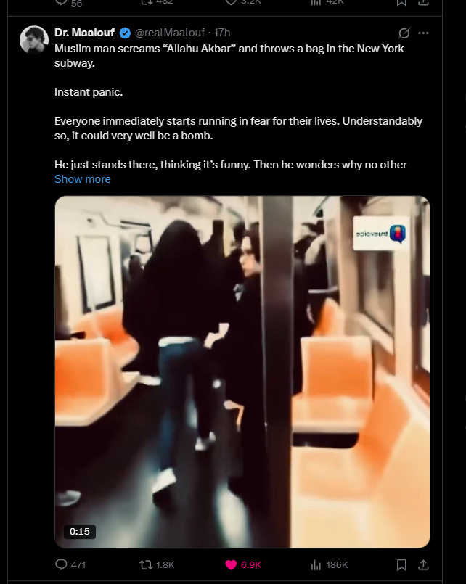

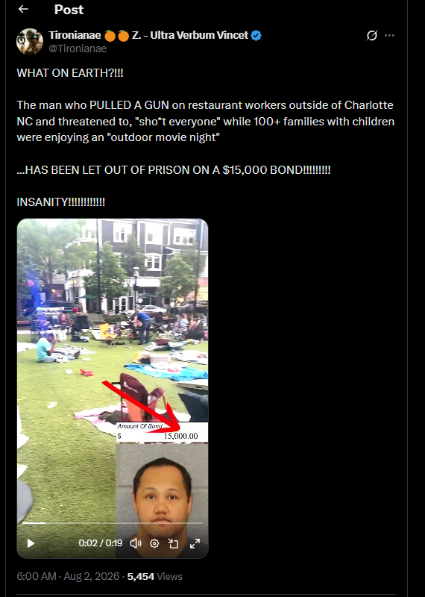
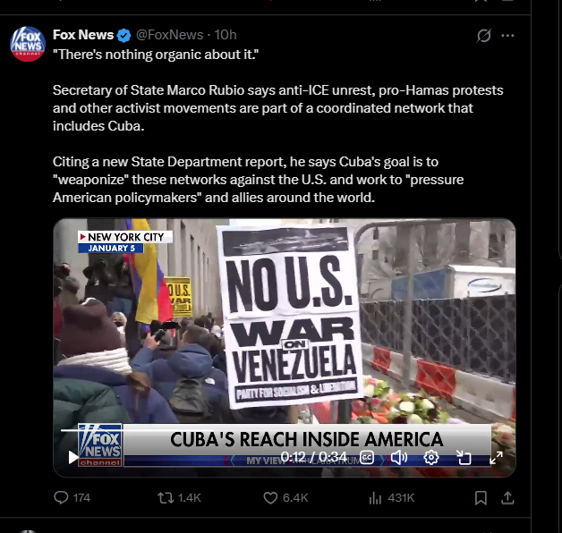
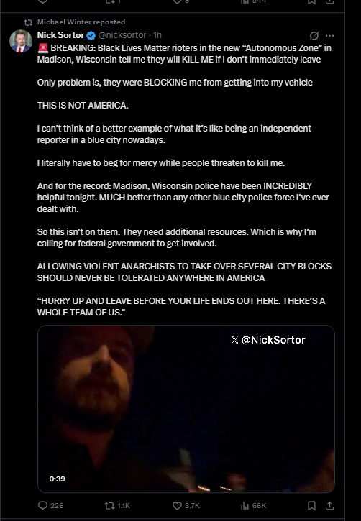
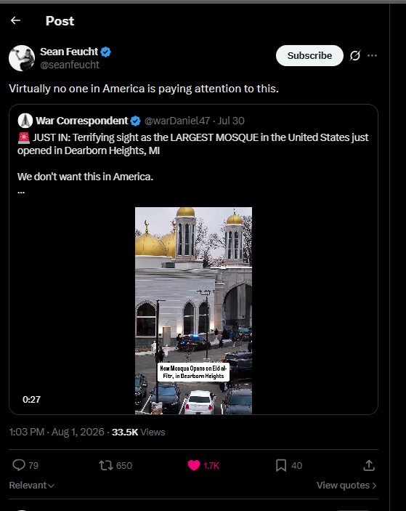
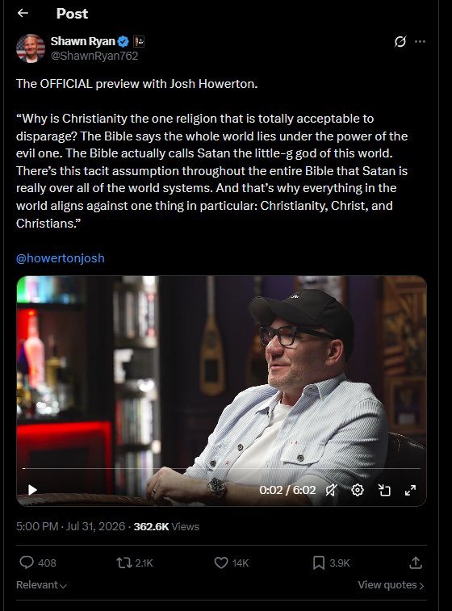

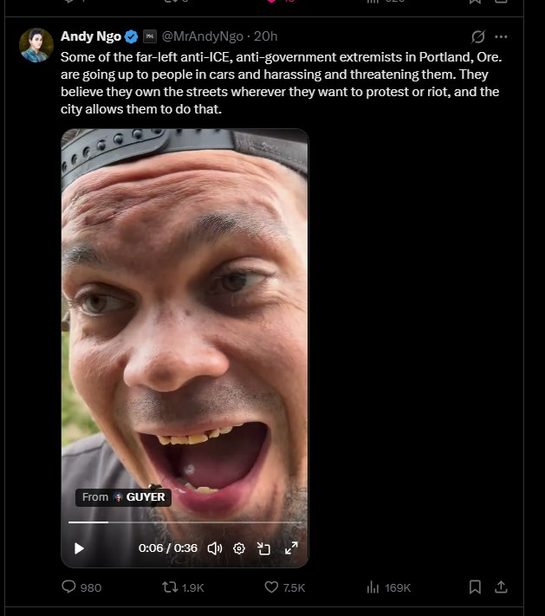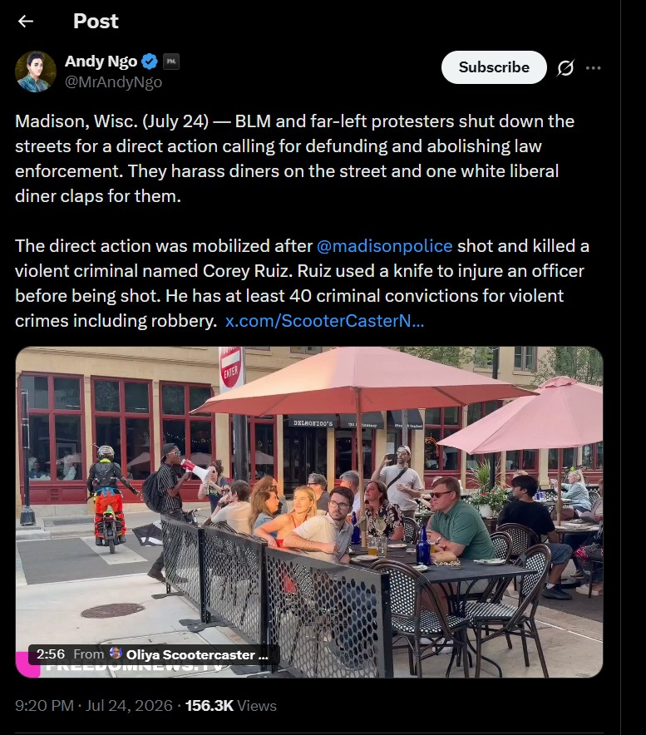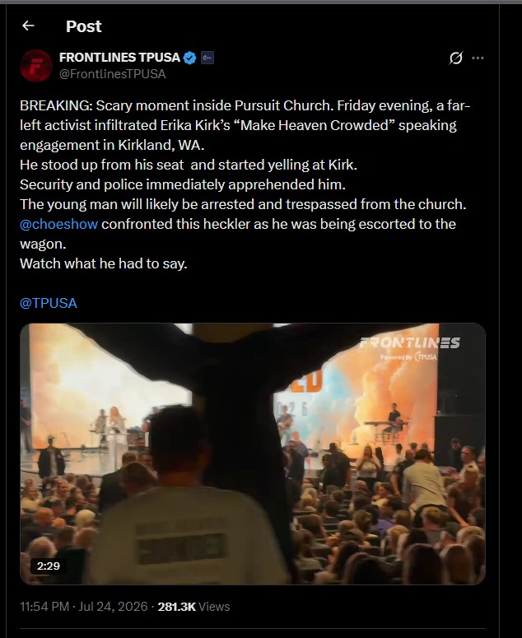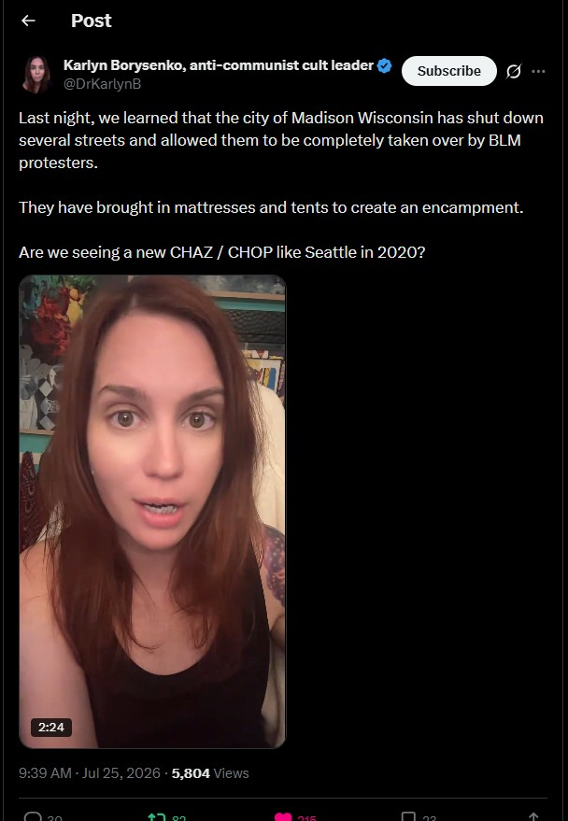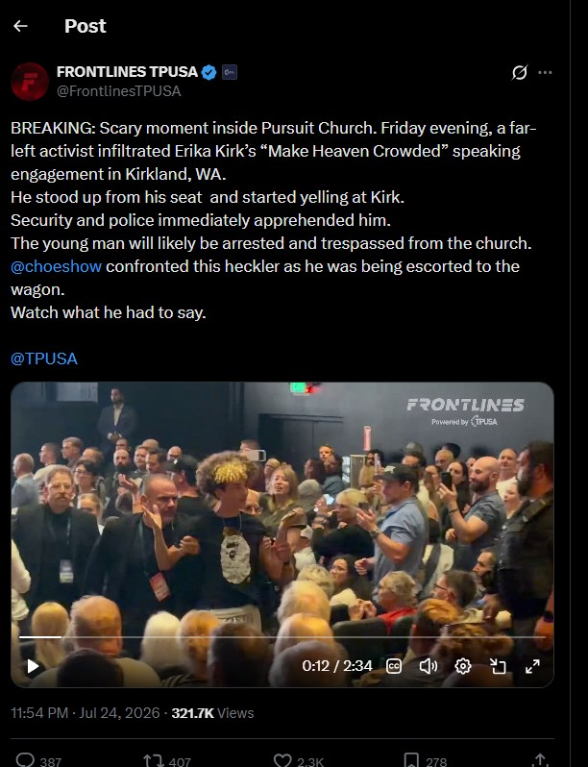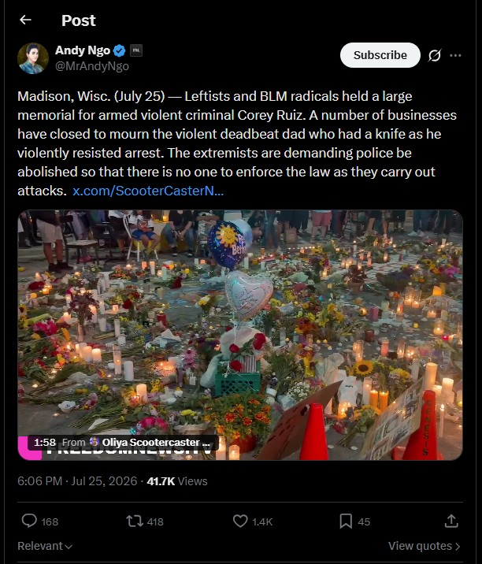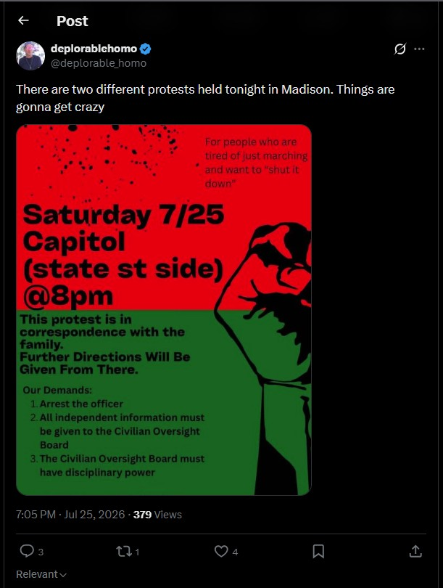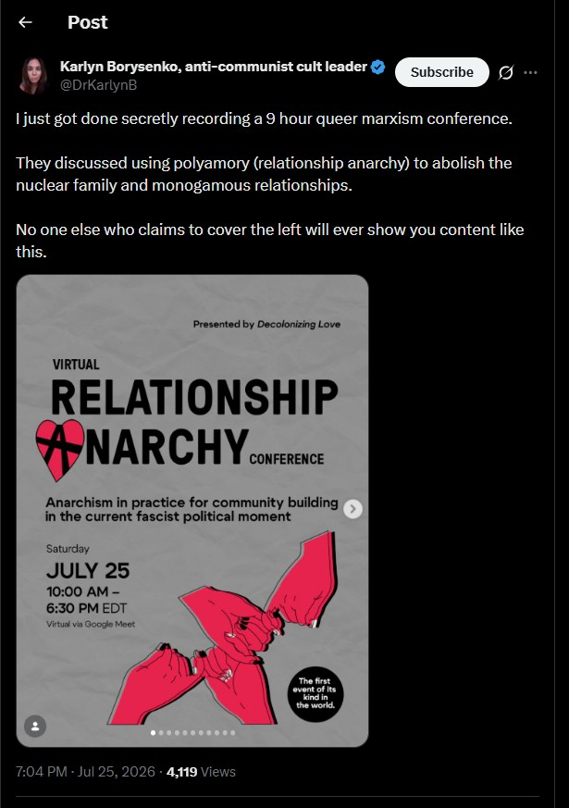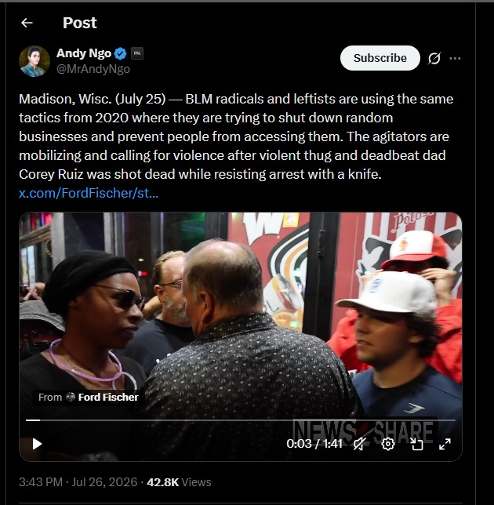

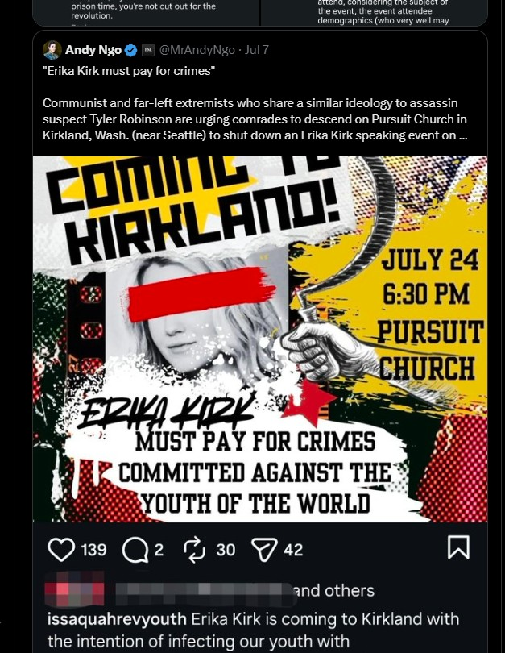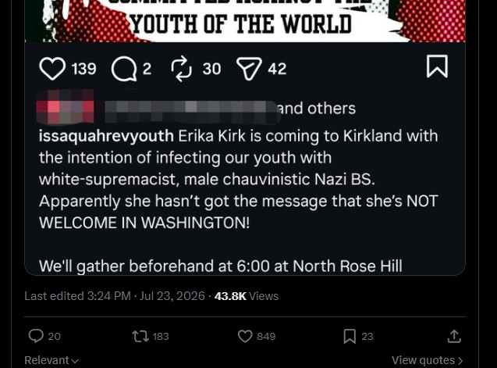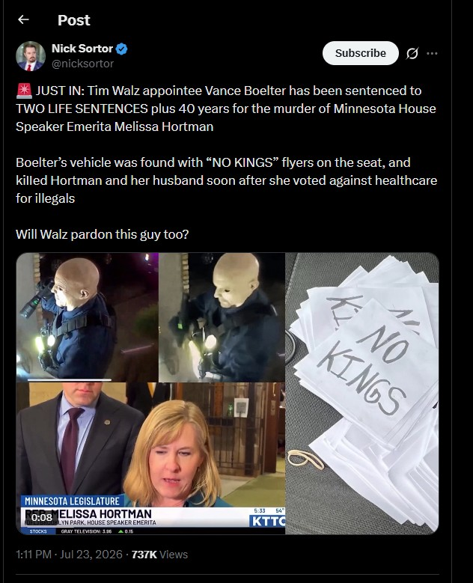
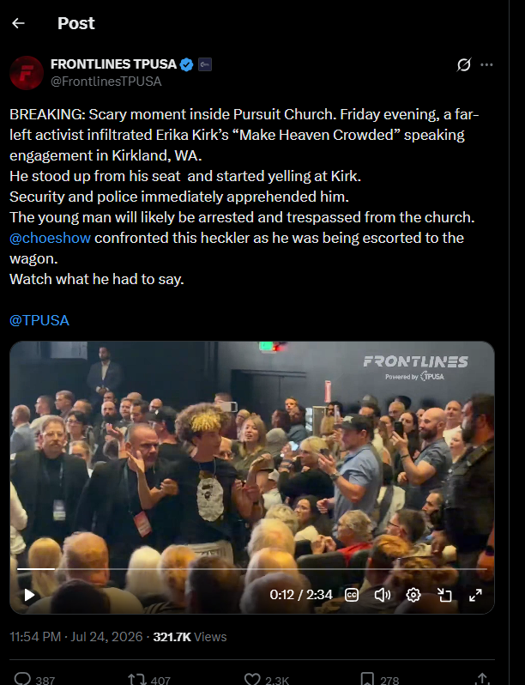
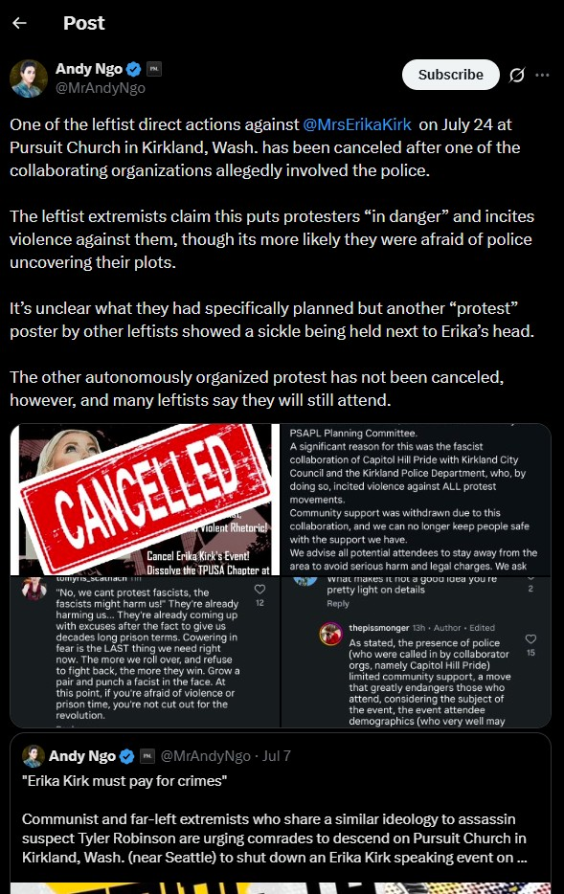
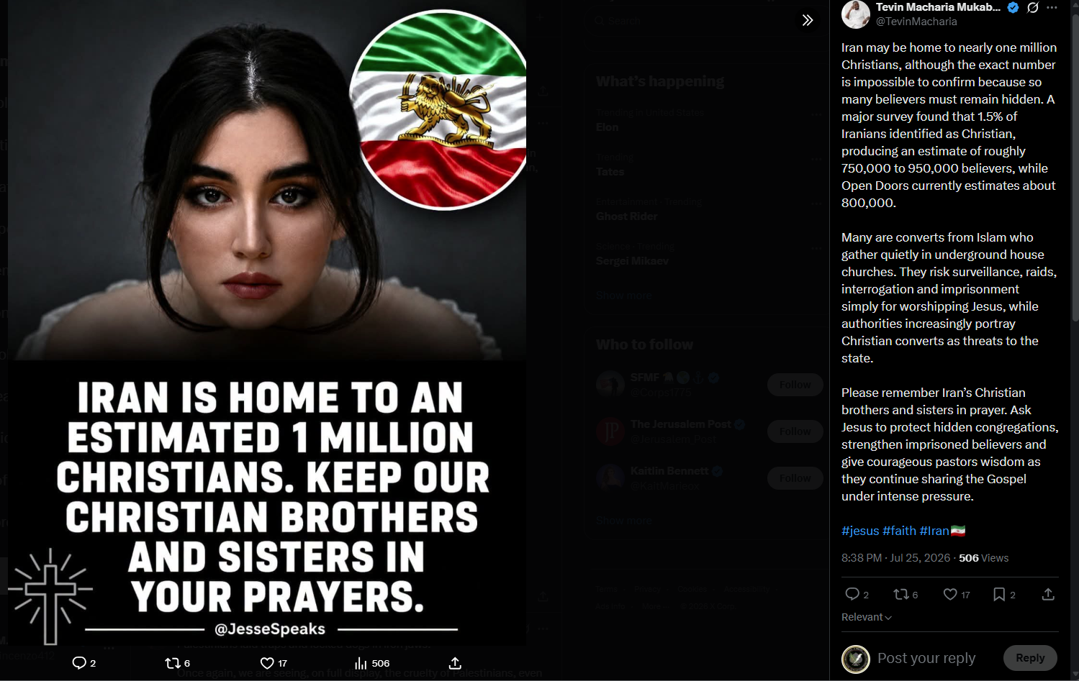

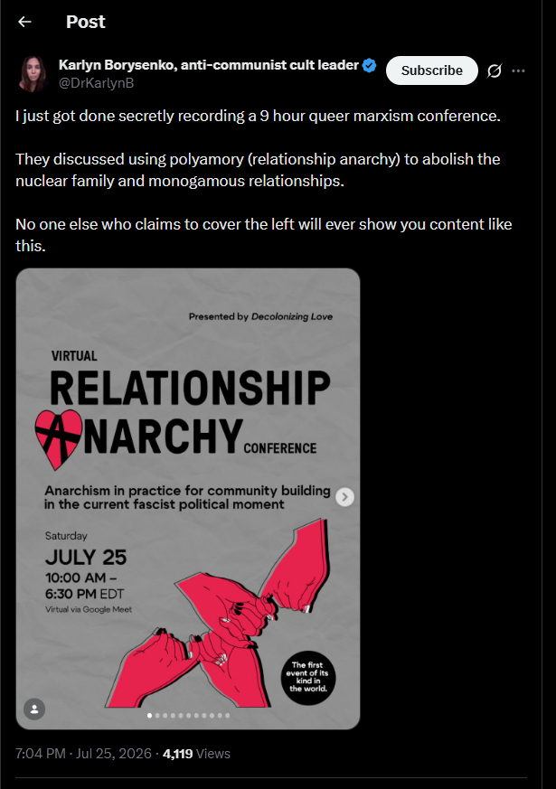
///END///
====================================================================
REQUEST WRITTEN PERMISSION, EMAIL, PRIOR TO DISSEMINATING ANY IN OBSCURA PRODUCTS OR INFORMATION.

TRAFFIC LIGHT PROTOCOL REQUIREMENTS FOR DISSEMINATION
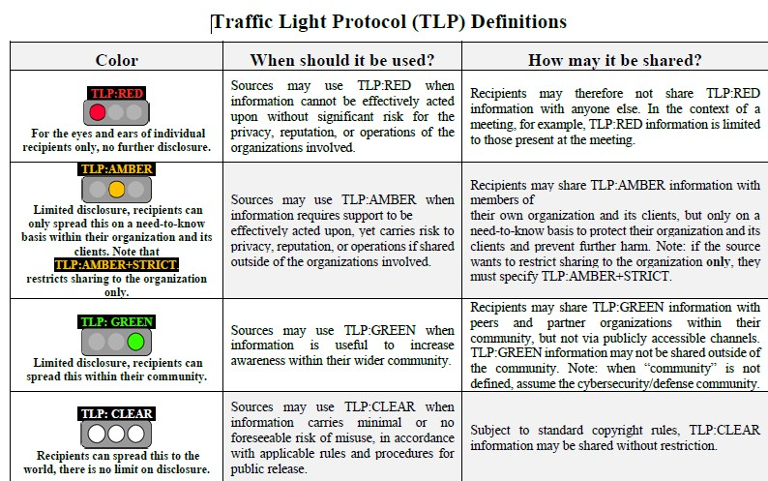

///END OF REPORT///

