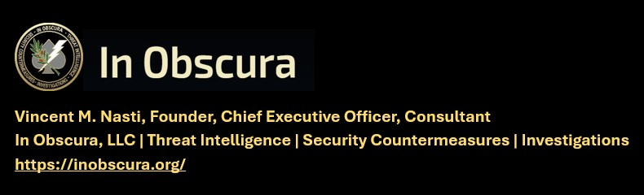

(TLP-C) THREAT WARNING AND SIGNFICANT ACTIVITY (SIGACT) 22 OCT 2026
KNOW THE TARGET – WATCH THE TARGET – LOOK DEEPER -EXPECT THE UNEXPECTED
Matthew 11:12 "And from the days of John the Baptist until now the kingdom of heaven suffereth violence, and the violent take it by force."
IN OBSCURA THEAT LEVEL – IMMINENT
---------------------------------------------------------------------------------------------------------------
CAVEAT: THIS INTELLIGENCE PRODUCT RELIES ON OPEN-SOURCE MEDIA OR GOVERNMENT RELEASED UNCLASIFIED INFORMATION. RECOMMENDED ACTIONS ARE INCLUDED FOR CLIENTS FOR INFORMATION AND ACTIONS DEEMED APPROPRIATE.
---------------------------------------------------------------------------------------------------------------
DATE OF ACQUISITION: 22 OCT 2026
PUBLISHED: 23 OCT 2026
COLLECTION PERIOD: 16-23 OCT 2026
INFORMATION CUTOFF: 23 OCT 2026
DISSEMINATION CONTROL: TRAFFIC LIGHT PROTOCOL-CLEAR (TLP-C)
PREPARED BY: V.M. NASTI
POINT OF CONTACT: V.M. NASTI

EXECUTIVE SUMMARY
Collection of Open Source Intelligence (OSINT) this period, in context, evidences a substantial escalation in each phase of irregular and unconventional warfare. Numerous domestic groups identified in prior reporting by In Obscura are active in every phase of insurgency with known guerilla and unconventional warfare TTP deployed. This escalation was also noted and reported and spreading across Europe concurrently with target surveillance and probes of security and precursor attack scenarios including government leaders recently imploring their citizens to prepare for war and attacks.

Mission focus at in Obscura is the Christian Church and other houses of worship in protection strategies applied locally to the Washington, DC National Capital Region. Itself the largest target in the free world for the phases of terrorist attacks. In Obscura has been tracking the gradual escalation over a protracted period of time is as predicted, an escalation and overt operations, portending an attack potential scenario. It is reiterated that I have reported on the known and unpublished pre-operational attack targeting, intelligence collection of churches in the U.S. and its myriad attacks over just the last five years alone.

TERRORISM, UNCONVENTIONAL WARFARE, TARGETING
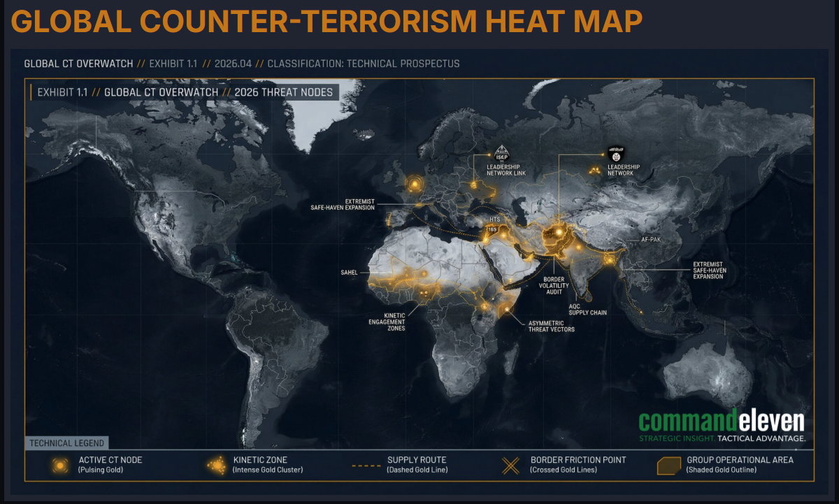
 https://commandeleven.com/

FBI arrests alleged Islamic State supporter accused of plotting to assassinate Texas congressman, Will Selber, Long War Journal, Foundation for Defense of Democracies
October 23, 2026, https://www.longwarjournal.org/archives/2026/10/fbi-arrests-alleged-islamic-state-supporter-accused-of-plotting-to-assassinate-texas-congressman.php

Federal authorities arrested a 17-year-old Texas boy accused of plotting to assassinate Rep. Keith Self, R-Texas, and carry out a separate terrorist attack in North Texas on behalf of ISIS, according to a local report. Self’s campaign told NBC 5 Dallas-Fort Worth that investigators believed the teenager was planning a terrorist attack in North Texas on behalf of the Islamic State. He also allegedly intended to target Self at an October 17 chili cook-off fundraiser for veterans involving former Dallas Cowboys players and other prominent guests.

Federal law enforcement sources also told the local news affiliate that the suspect was arrested after acquiring a firearm. The sources said the teenager had recently become radicalized and was under federal surveillance. His name has not been publicly released, and he remains in federal custody.

Self’s campaign manager said that US Capitol Police notified his team on October 6, the day after the arrest. Self said he increased security but attended the October 17 fundraiser as scheduled, where he judged chili and beans.

Far-left podcaster calls for 'pistols firing' toward JD Vance, defeating him in 2028
Welch also argued Vance is a 'failed drag queen' and an 'antichrist-style sociopath'
By Alexander Hall Fox News, Published October 22, 2026 8:52pm EDT
https://www.foxnews.com/media/far-left-podcaster-calls-pistols-firing-toward-jd-vance-defeat-him-2028

Podcaster Jennifer Welch called for the defeat of Vice President JD Vance and urged people to keep "pistols firing" toward him, drawing criticism on social media Tuesday.
During a recent segment on the "I’ve Had It" podcast, Welch condemned Vance, arguing that, during his "woke era," he married second lady Usha Vance, an Indian American, and had children but now views his family as a burden as he seeks to portray himself as President Donald Trump's successor as leader of the MAGA movement.
"I don't know what Peter Thiel did to him. I can only imagine," she said of the billionaire megadonor who has been a longtime benefactor of Vance. "You can only imagine.

“Kill Lots of Jews”: East Jerusalem Pharmacy Student Planned Mass-Casualty Terror Attacks Using Deadly Poisons, Yeshiva World, October 8, 2026, https://www.theyeshivaworld.com/news/israel-news/2607213/kill-lots-of-jews-east-jerusalem-pharmacy-student-planned-mass-casualty-terror-attacks-using-deadly-poisons.html

The State Attorney’s Office filed an indictment Thursday with the Jerusalem District Court against Muhammed Shalabi, a 22-year-old pharmacy student from Jerusalem’s Beit Hanina neighborhood on charges of planning mass-casualty terrorist attacks, targeting security forces and Jewish civilians using explosives and deadly poisons.

Shalabi is charged with preparing to commit a terrorist act of murder and receiving training for terrorist purposes. Prosecutors have requested that he remain in custody until the conclusion of legal proceedings. According to the indictment, filed at the Jerusalem District Attorney’s Office, Shalabi, a third-year pharmacy student who also worked as a pharmaceutical assistant, underwent a process of ideological radicalization following the October 7 massacre and the subsequent war.

During this period, he regularly attended a mosque in Beit Hanina and systematically consumed Hamas- and ISIS-affiliated content, later deciding to exploit the knowledge he had acquired through his studies and his access to chemical substances to carry out deadly terrorist attacks.

Chandler man arrested on suspicion of making threats against religious sites
KJZZ | By Matthew Casey
https://www.kjzz.org/kjzz-news/2026-10-19/chandler-man-arrested-on-suspicion-of-making-threats-against-religious-sites

Authorities on Friday arrested a Chandler man on suspicion of having made terroristic threats against houses of worship. Police say they found three firearms and instructions for making explosives when they searched Matthew Bjornholt’s home.
The 27-year-old with suspected ties to white supremacists allegedly told a friend he planned to carry out a mass attack on a Jewish synagogue or Muslim mosque.
Authorities say Bjornholt intended to make good on the threat during the next major religious holiday. Court records show Bjornholt was previously incarcerated and recently released from behavioral health treatment.

Feds investigate suspicious mailings sent to members of Congress and state election officials, NBC, Oct. 15, 2026, 12:38 PM EDT / Updated Oct. 15, 2026, 8:33 PM EDT
By Frank Thorp V, Julie Tsirkin, Andrew Arenge, Rebecca Shabad and Raquel Coronell Uribe, https://www.nbcnews.com/politics/2026-election/authorities-investigate-suspicious-mailings-congressional-offices-rcna603712

The offices of several Democratic senators, including Senate Minority Leader Chuck Schumer of New York, were targeted. Election offices in at least 15 states — Arizona, Delaware, Georgia, Idaho, Kansas, Louisiana, Nebraska, New Hampshire, Ohio, Oklahoma, Pennsylvania, South Dakota, Tennessee, Washington and Wisconsin — said they were mailed suspicious packages. The FBI, U.S. Capitol Police and the U.S. Postal Inspection Service were looking into the mailings, according to a notice sent to senior staff members in Senate offices Thursday.

IN OBSCURA COMMENT
This is assessed as terrorist “stress-up fear” and tests of security phases within the toality of an escalating global threat environment. Churches and Houses of Worship MUST examine each mail piece, packages included, carefully and in detail before deciding to open them. Many are from familiar senders, but it only takes one, while distracted to exploit the intended target. Part of this detection includes unattended envelopes or packages found outside a church door or in the parking lot. Trust your instincts and call 911 and maintain a large distance. See the following Postal Service guidance:


‘Lost their minds’: Hundreds of teens vandalize Huntersville church, fire shots in takeover, People seen running for cover in surveillance video, Surveillance video shows gunshots ringing out in the Faith City Charlotte church parking lot around 2 a.m. By Connor Lomis Published: Oct. 21, 2026 at 10:41 AM EDT, Connor Lomis, WBTV,
https://www.wbtv.com/2026/10/21/lost-their-minds-hundreds-teens-vandalize-huntersville-church-fire-shots-takeover/

“I think enough is enough. People are frustrated. This is their church. We’ve given all we’ve got, and it’s like we’re sitting ducks,” May said.
May said the dead-end road next to the church is often a hotspot for dumping, drug use, and doing donuts, and tire marks have now spilled into the church parking lot.

“We asked the city to get involved, to give us a roadblock or some barriers because if not, they’re going to continue to do this,” May said. Bishop Amere May said the dead-end road next to the church is often a hotspot for dumping. Bishop Amere May said the dead-end road next to the church is often a hotspot for dumping, drug use, and doing donuts, and tire marks have now spilled into the church parking lot. (WBTV) May said the church installed fencing to curb the takeovers, but teens destroyed it each time it was rebuilt.

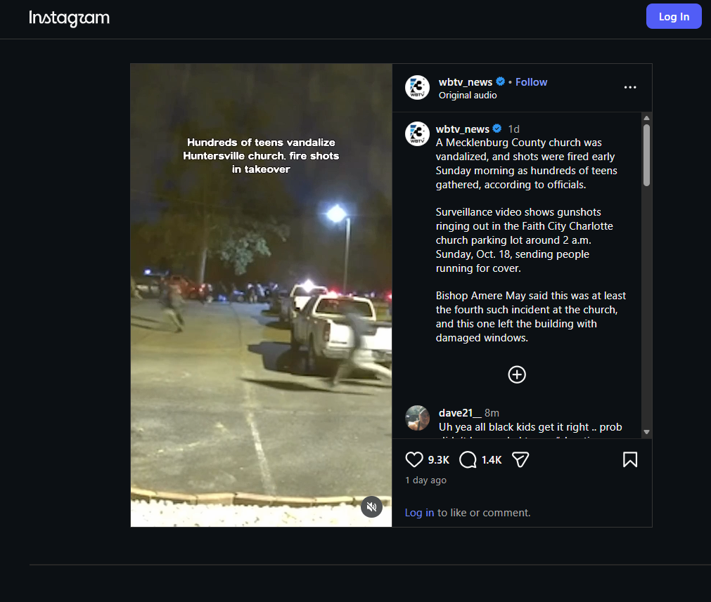
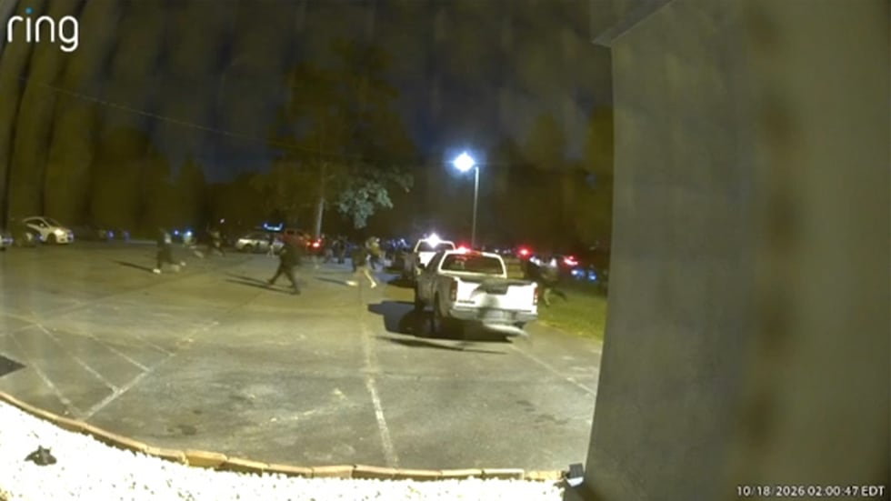

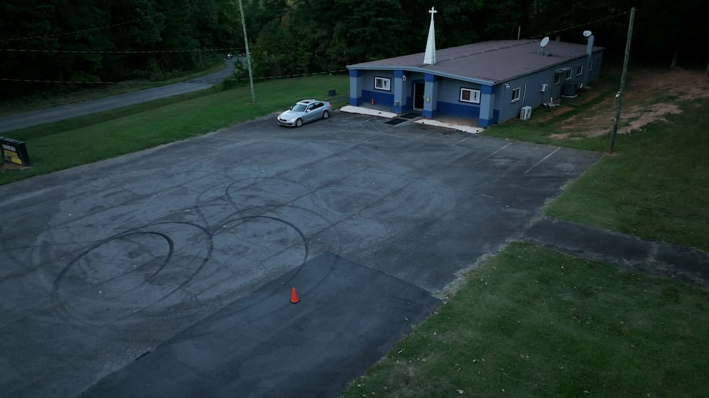

###
Man uses a sledgehammer to behead Iwo Jima monument soldier, When police arrived, officers found the man using a sledgehammer to damage the monument.
Author: Alanea Cremen, WUSA9, Published: 11:40 AM EDT October 22, 2026
Updated: 12:17 PM EDT October 22, 2026 https://www.wusa9.com/article/news/crime/man-sledgehammer-behead-iwo-jima-monument-soldier/65-5c1664f7-edda-4e29-98fa-5a8f564ac00e?utm_campaign=snd-autopilot

QUANTICO, Va. — A Stafford man is facing charges after police say he beheaded one of the soldiers at the Iwo Jima statue in Quantico. According to the Prince William County Police Department, 27-year-old Miguel Alonso Maldonado Soriano has been charged with felony destruction of property, trespass with intent to damage property, and felony
injury to a monument. Officers were called to the statue near Richmond Highway and Fueller Road just before 10:15 p.m. on Tuesday. When they arrived, they found Maldonado Soriano using a sledgehammer to damage the monument. Twitter (X) post follows:

St. Louis church leaders seek answers after 46 reported burglaries, thefts
Fox2Now, by: Kamryn Mendoza, Posted: Oct 15, 2026 / 10:09 PM CDT, Updated: Oct 15, 2026 / 10:13 PM CDT https://fox2now.com/news/missouri/st-louis-church-leaders-seek-answers-after-46-reported-burglaries-thefts/

ST. LOUIS — Church leaders gathered Thursday night at Kennerly Temple Church to discuss theft and burglary concerns after dozens of burglaries and thefts targeting places of worship within the city limits this year. Church leaders said their congregations have taken precautions but continue to be targeted.

At Mount Ivory Missionary Baptist Church, a representative said the church has dealt with repeated air conditioning thefts, with units broken into three times, but reported it only happens around May. Pastor Edgar Madison, who hosted Thursday’s meeting, said his church has also suffered significant damage to air conditioning units, losing air for the entire summer. Madison said they recently just got their air conditioning repaired.

Sacramento man accused of bomb threats, threats against children at church
A Sacramento man faces federal charges after allegedly posting threats to kill children at a nearby church and carry out a mass shooting. Author: Staff (ABC10), Published: 5:09 PM PDT October 21, 2026 Updated: 5:09 PM PDT October 21, 2026
https://www.abc10.com/article/news/crime/sacramento-man-accused-of-bomb-threats-threats-against-children-at-church/103-0cc3b343-3bbc-44e7-8e21-fc5f2e71230e

SACRAMENTO, Calif. — A Sacramento man was charged by indictment with making interstate threats, threats involving explosives and possession of ammunition as a prohibited person, U.S. Attorney Eric Grant announced Tuesday.
According to court documents, Lo Saetern, 35, posted numerous threats to YouTube between Sept. 15 and Sept. 21, 2026, about wanting to build a bomb and kill children at a nearby church. He also made statements about wanting to carry out a mass shooting targeting Muslims and to rape, kill and mutilate his neighbor’s daughter.

WHO'S WHO: Inside France's 'Chaos Inc' franchise of communist groups, labor unions and global activists Fox News Digital investigation identifies 54 groups behind France's unrest as communists prepare a November youth strike, Asra Q. Nomani By Asra Q. Nomani Fox News, Published October 19, 2026 4:00am EDT | Updated October 19, 2026 4:02am https://www.foxnews.com/world/whos-who-inside-frances-chaos-inc-franchise-communist-groups-labor-unions-global-activists

A Fox News Digital investigation has identified 54 organizations and movements in France's October student protests and their wider network of supporters and international amplifiers, including communist parties, revolutionary socialist groups, labor unions, environmental activists, Muslim student advocates, Palestinian-solidarity organizations and international media outlets.

Of the 54 organizations identified in the October protest ecosystem, 16 — or only about one in three — are student or youth organizations, including communist youth groups and a Muslim student association. The remaining 38 include adult-led communist groups, labor unions, political parties, revolutionary-left organizations, advocacy groups and international propaganda outlets.

“Fu*k Your Mothers, You Christians!” The Muslim Persecution of Christians, June
Raymond Ibrahim, Substack, 16 Oct 26, https://raymondibrahim.substack.com/p/fuk-your-mothers-you-christians Gatestone Institute

The following are among the murders and abuses Muslims inflicted on Christians throughout the month of June 2026. The Muslim Slaughter of Christians
Democratic Republic of Congo: Islamic terrorists slaughtered hundreds of Christians in separate attacks. Then, on June 3, and again on June 24, Muslim militants beheaded a total of 14 Christians.

‘We Are The Majority’: Watch Mehdi’s Rousing Speech at the No Kings Protest in DC,
Zeteo's editor-in-chief joins Sen. Bernie Sanders, 'Science Guy' Bill Nye, and others in the nation's capital, in front of a crowd of tens of thousands, to oppose ‘wannabe dictator’ Donald Trump. Team Zeteo, Oct 18, 2025, https://zeteo.com/p/no-kings-protest-mehdi-trump

Mehdi also joked about how he is “everything Donald Trump loves” – a journalist, an immigrant, and a Muslim. “The Trump trifecta!” He then went on to take his own digs at the “the whiny authoritarian man-child currently sending troops to as many blue cities as he can. Mehdi also slammed Trump’s so-called ‘peace plan’ for Gaza, telling the crowd that the US president has, “no plan for Palestinian freedom, no plan for Palestinian
statehood, no plan for justice for the Palestinians of Gaza.”

Yet, in spite of the grim state of the world, Zeteo’s founder and editor-in-chief reminded the crowd that there is power in numbers. In a powerful moment, he asked the crowd, “Are you willing to sit back and let Trump shred our freedoms?” – to which thousands responded, in unison, with a loud and resounding “NO!”

No Kings: The Radical Undercurrents and Foreign Entities Behind the 50501 Protest Movement Note: July 7, 2025
https://itsyourgov.org/articles/no-kings-the-radical-undercurrents-and-foreign-entities-behind-the-50501-protest-movement IN OBSCURA previously posted this report in pdf form on our website upon publication.

Oversight Project’s recent investigation into the 50501 movement—an organizer of the nationwide “No Kings” protests—reveals troubling associations with extremist far-left, communist, and foreign-aligned organizations. Though the protests were framed by mainstream media as pro-democracy, analysis of 50501’s social media networks shows repeated connections to groups like the Party for Socialism and Liberation (PSL), Democratic Socialists of America, Antifa, and Students for Justice in Palestine. Several of these groups have supported violent actions or foreign authoritarian regimes, including China’s Communist Party. The dataset also uncovered links to foreign influence networks backed by individuals tied to CCP propaganda efforts:
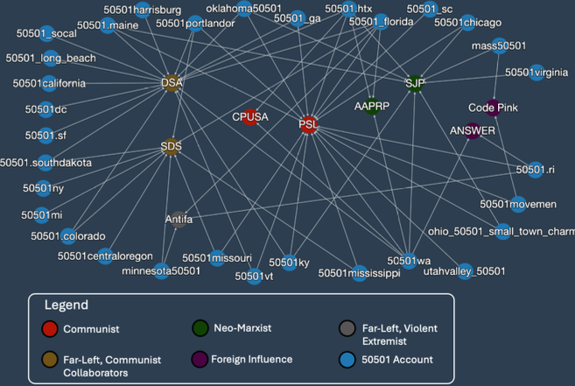

Despite this, media outlets like NPR largely ignored these affiliations, portraying the movement as a grassroots coalition of concerned citizens. Alarmingly, 50501 accounts were more likely to follow radical groups than mainstream media or Democratic politicians. This raises concerns that the movement may serve as a Trojan horse for extremist ideologies masked under a democratic banner—further blurring the line between activism and ideological subversion. View the full report below or linked here.
Police find weapons and anti-government symbols in Alabama home after threats to ICE, By Hudson Crozier, Published October 8, 2026 1:07pm ET | Updated October 8, 2026 1:07pm ET, https://www.washingtonexaminer.com/news/investigations/4758931/three-arrested-alabama-threats-ice-immigration-enforcement/

A runaway teenager’s string of police encounters and alleged threats to kill immigration agents led to three arrests in Alabama last month, court records show.

Law enforcement tracked 18-year-old Levi Belcher of Tennessee after noticing threats on social media in December 2025, and after being reported missing by the suspect’s father the following month, the FBI alleged in criminal complaints. Investigations ultimately led Alabama police to search a Huntsville apartment on Sept. 10 to find it “littered with anti-government writings,” plus a rifle with “anti fascist” written on it, according to the charging documents.

Satanism Grows Bolder in Hatred of the Holy, But Catholics Resist
In the face of continuing and growing interest in Satanism, the Catholic Church remains resolute in defending the Faith. Kathy Schiffer, February 9, 2022, EWTN, https://ewtn.co.uk/article-satanism-grows-bolder-in-hatred-of-the-holy-but-catholics-resist/

“Our struggle is not with flesh and blood,” wrote the Apostle Paul in his Letter to the Ephesians, “but with the principalities, with the powers, with the world rulers of this present darkness, with the evil spirits in the heavens.”
Sometimes it seems that the evil spirits about whom Paul writes are working overtime in America! In recent months — really, in the past few years — reports of Satanism have risen sharply. Destruction in the Name of the Devil

In New Haven, Connecticut, St. Joseph’s Church suffered damage in July 2020 when vandals painted a Satanic pentagram and an anarchy symbol on the church doors. The Archdiocese of Hartford saw this as part of a larger national problem and wrote, “This follows an apparent trend of desecrating Catholic spaces throughout the nation, as evidenced by incidents in Chattanooga, Queens, Boston, Sacramento, and Ocala.”

Since that time there have been a number of similar incidents. At Good Shepherd Catholic Church in Florida, a statue of Jesus was decapitated. In Colorado Springs, a statue of the Virgin Mary was defaced with red paint and the word “redrum” was painted on its base. (“Redrum” is “murder” spelled backwards, and is generally believed to refer to the 1980 Stanley Kubrick film “The Shining.”) In California, the historic San Gabriel Mission, which was founded by St. Junípero Serra in 1771 and which contained many irreplaceable artifacts, was destroyed by arson.

Northern Ireland schools evacuated after 'Islamist' bomb threats as parents told to 'come immediately' to collect their children, GB News, By Ben McCaffrey
Last updated: 19th October 2026, 8:14am

The Education Authority (EA) said it is 'aware' of the email that had been sent
WATCH: Northern Ireland First Minister role under threat
https://www.gbnews.com/news/northern-ireland-school-bomb-threat-schools-evacuated-explosive-device-email-parents-collect-children

Schools in Northern Ireland have been forced to evacuate after receiving an "Islamist" bomb threat via email. Stormont Education Minister Paul Givan confirmed this morning the message, which warned there was "viable devices" within the institutions, had been sent to more than 160 schools and was "signed off 'Allah Akbar'".
A spokesman for the Police Service of Northern Ireland also said officers had received reports of the threatening emails.

FRANCE: Churches attacked in the last 10 years – Each red dot = one church attacked
Scritto daadmin RGX Live
https://rgxlive.com/france-churches-attacked-in-the-last-10-years-each-red-dot-one-church-attacked/

France: a church attacked every 15 days. The map no one wants to show you. In France, a religious building disappears every two weeks. It’s not a theory – it’s the Observatory of Religious Heritage (OPR). Fires, vandalism, planned demolitions. Two-thirds of fires show signs of arson. Look at the map. Every red dot is a church attacked in the last 10 years. The official numbers from the French Interior Ministry for 2025 are brutal:

843 anti-Christian incidents in 2025 – up 9% from 2024. That’s 34% of all anti-religious acts in France.
627 attacks on Christian places of worship alone – up 8%.
45 arson attacks against churches in 2025 alone.
Breakdown: 362 thefts or attempted thefts (43%), 254 vandalisms (30%), 81 graffiti (10%).
And the worst trend: disruptions of services and threats against worshippers up 86% – 54 incidents vs 29 in 2024: 86 French senators signed an unprecedented appeal: “Not a week goes by without regional press reporting these attacks, from desecration and arson to physical assault.”

In the first 5 months of 2025 alone, 322 acts – +13%. The most hit regions? Exactly what you see on our map: Île-de-France, Auvergne-Rhône-Alpes, Provence-Alpes-Côte d’Azur, Nouvelle-Aquitaine and Grand Est. And while a church disappears every 15 days in France, a new mosque is built every 15 days in the same country. Today: 2,600 mosques in France.

Over 12,000 in Europe. On the other side?
Saudi Arabia: 0 churches. Forbidden by law. 2 million Christians must pray in secret.
Qatar: 6 official churches, all locked inside one compound in the desert outside Doha – the Mesaimeer Religious Complex. No crosses outside, no bells.
Bahrain: 19 churches, the most tolerant in the Gulf.
In Europe they burn churches. In the Gulf they don’t even let you build them. Zero reciprocity. This is not integration. This is replacement.

IN OBSCURA COMMENT
Current OSINT collection efforts indicate but are not specific to the church and synagogue direct action attacks across Europe during this alleged riot which is devouring all of Europe as expected.
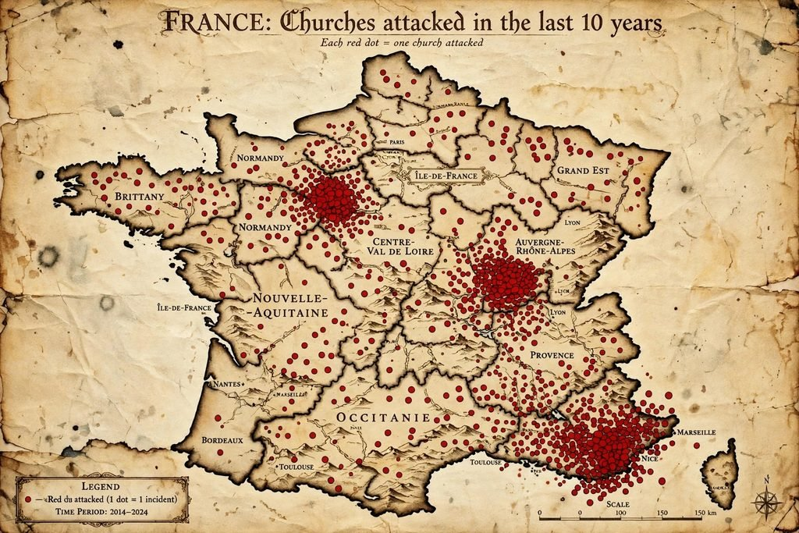

CHRISTIAN ADVERSITY, HATE, PERSECUTION
Religiously Woke: Dean of Students Warns that Saying, “In Christ Alone” Constitutes “White Privilege,” Jonathan Turley, 132 Oct 26https://jonathanturley.org/2026/10/13/religiously-woke-dean-of-students-warns-saying-in-christ-alone-constitutes-white-privilege/

My recent USA Today column discusses how the Democrats have suddenly discovered God in elections after recruiting various far-left ministers to run on faith-based anti-Trump messages. I discussed how Divinity Schools have shown the same trend as other departments in higher education with a radical shift to the left. That was evident in a controversy this week at Point Loma Nazarene University, where Dean of Students Jason Cha told student leaders that identifying as being “in Christ alone” is a sign of “white privilege.”

Ella Langley says canceled concert was ‘not worth a human life’ after bomb threat
The country star revealed that she nearly canceled her next performance in Texas because of the scare Ashley Hume By Ashley Hume Fox News
Published October 11, 2026 8:21pm EDT https://www.foxnews.com/entertainment/ella-langley-canceled-concert-not-worth-human-life-bomb-threat

Langley said, “The most important thing in this life is that you wake up every day and feel like, ‘You know what, I’m good today. I am so grateful to have woken up today.’” She added, “The most important thing in this life, No. 1, is your relationship with Jesus Christ.”

Ella Langley Points Fans to Jesus After Canceling Concert Over Bomb Threat
October 12, 2026
By Stephanie Martin, Church Leaders
https://churchleaders.com/news/2223816-ella-langley-jesus-canceling-concert-bomb-threat.html

15,000-Member Texas Megachurch Weighs United Methodist Church Exit as Legal Battle Escalates By Abby Trivett Oct 15, 2026, MyCharisma,
https://mycharisma.com/news/15000-member-texas-megachurch-weighs-united-methodist-church-exit-as-legal-battle-escalates/

Now, the conflict has taken another dramatic turn. According to United Methodist News, church leaders held a town hall on Oct. 1 to discuss whether Highland Park should remain affiliated with the denomination. “The question is: Knowing what we know now, should our church remain part of The United Methodist Church?” church council Chair Caroline Nowlin asked.

They Want to Burn It Down and Rule Over the Ashes': Are Christians Safe in Canada (Video) RAIR October 21, 2026, https://rairfoundation.com/they-want-burn-it-down-rule-ashes-are/

Oklahoma State Senator Shane Jett gave the keynote. Stockwell Day, former leader of the Canadian Alliance and a federal cabinet minister under Stephen Harper, introduced him. Jett is a full citizen of the Cherokee Nation, a former Navy intelligence officer, a Trump appointee to the U.S. Treasury’s Community Development Advisory Board, and the founding chair of the Oklahoma Freedom Caucus. He came to Ottawa because the Canadian Charter of Rights and Freedoms opens by acknowledging “the supremacy of God and the rule of law,” and Bill C-9 sits in growing tension with that inheritance.
The keynote was a sermon about courage. Jett is a Bible-believing Christian, and he preaches like one. He told the story of Gideon, the coward in the wine press whom God called a mighty man of valor. He told the congregation they were not alone. He quoted Revelation 21:8 on the fearful and the cowardly. He said courage is contagious.

NY political leaders warn anti-Zionist group against targeting Jewish events
By Luke Tress, Times of Israel, 22 Oct 26, Times, https://www.timesofisrael.com/liveblog_entry/ny-political-leaders-warn-anti-zionist-group-against-targeting-jewish-events/

New York elected leaders warn the Pal-Awda anti-Zionist activist group against targeting Jewish events ahead of a protest planned for Saturday in the Riverdale neighborhood of the Bronx. US Congressmen issued a joint warning to the group. The lawmakers are all from the Bronx.

Pal-Awda has led a series of protests targeting events at synagogues in recent years.
The protests target events linked to Israel, such as immigration forums and real estate marketing sessions. The events typically have minor links to the West Bank.
The demonstrations often include harassment of Jews and support for terror groups in Jewish neighborhoods.

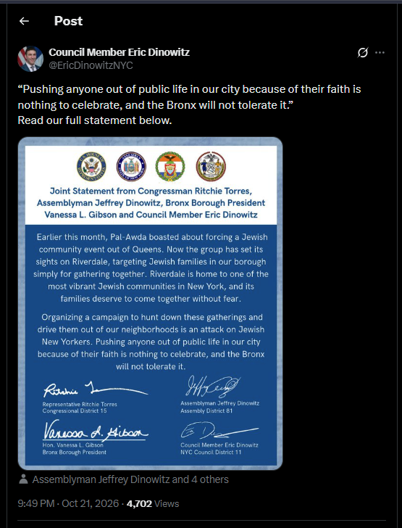

Historic NYC churches and landmarks at risk of being razed for the sake of ‘affordable housing’ By Chadwick Moore, NY Post, Published Oct. 15, 2026, 6:36 p.m. ET
https://nypost.com/2026/10/15/real-estate/historic-nyc-churches-and-landmarks-at-risk-of-being-razed-for-the-sake-of-affordable-housing-sources/

New York City has stopped awarding historic landmark designations, leaving some of the city’s most notable old buildings at risk of being razed. According to city records, no buildings are currently even under consideration by Mayor Zohran Mamdani’s Landmarks Preservation Commission (LPC), the department charged with protecting sites of beauty and significance from bulldozers.

That puts this year on track to be the worst ever for preservation since the department began in 1965.

“Without landmark protection, it’s very likely that eventually all of the historic buildings, the tenements, the old synagogues and churches, the institutional buildings will be demolished and turned into luxury housing and expensive hotels, the way things are going,” Richard Moses, president of the Lower East Side Preservation Initiative, told The Post of the current climate.

The socialists who have taken over have a dim view of preserving old buildings, particularly houses of worship, because they’d rather see more affordable apartments. They claim keeping churches from being torn down isn’t “equitable.”
Preservationists are particularly alarmed over the fate of Most Holy Redeemer church on East 3rd Street in Manhattan’s East Village — a granite and limestone cathedral built in 1851 by German missionaries.

GENERAL CRIME
Nothing Significant To Report (NSTR)
BOMB THREAT
NSTR

CHURCH ARSON, FIRE
Firefighters save historic NYC church famous for ‘Godfather’ scene from 4-alarm blaze
By Zoe Hussain NY Post, Published Oct. 18, 2026, 10:10 p.m. ET
https://nypost.com/2026/10/18/us-news/4-alarm-nyc-blaze-injures-1-spares-historic-godfather-church

One of the structures spared was Old Church of St. Joachim and St. Anne, which was famously featured in exterior shots of the baptism scene of Francis Ford Coppola’s “The Godfather.” The ornate Catholic church was also destroyed by a fire in 1973 and rebuilt three years later, the New York Times reported. Saturday evening’s fire was under control by 8:30 p.m., though firefighters continued to “put water on some of the hot spots” remaining there, Woods said.

Investigation underway into fire that heavily damaged Hanceville church
by Mary BarronTue, October 6, 2026 at 12:11 PM Updated Tue, October 6, 2026 at 1:05 PM
https://abc3340.com/news/local/hanceville-fire

A fire that tore through St. John’s Missionary Baptist Church in Hanceville has left the building badly damaged, and state investigators are now working to determine how it started. Flames broke out at the church, and hours later damage could still be seen. Hanceville Fire and Rescue needed help from six other fire departments to battle the fire. The Alabama State Fire Marshal’s Office is investigating what caused the fire. The cause has not been released. Interim pastor Wayne Wisener said the congregation is focused on those affected as it begins to process what happened. “When you are serving the lord, you can expect anything. It’s tragic. We think first of all about the young lady that’s involved,” Wisener said.

CYBER THREATS
NSTR
SPIRITUAL ACTIVITY
NSTR

SOCIAL NETWORKING INTELLIGENCE
Posts which provide threat indicators, sentiment, and atmospherics of interest to churches, clergy congregations, and those of other houses of worship.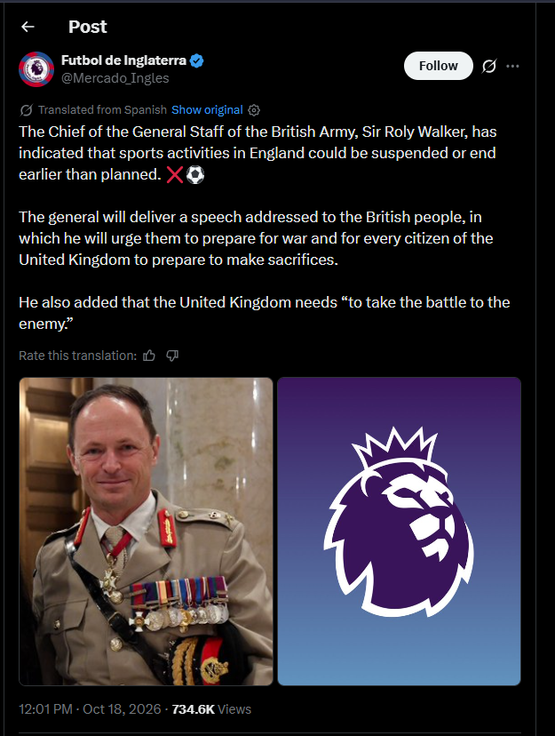

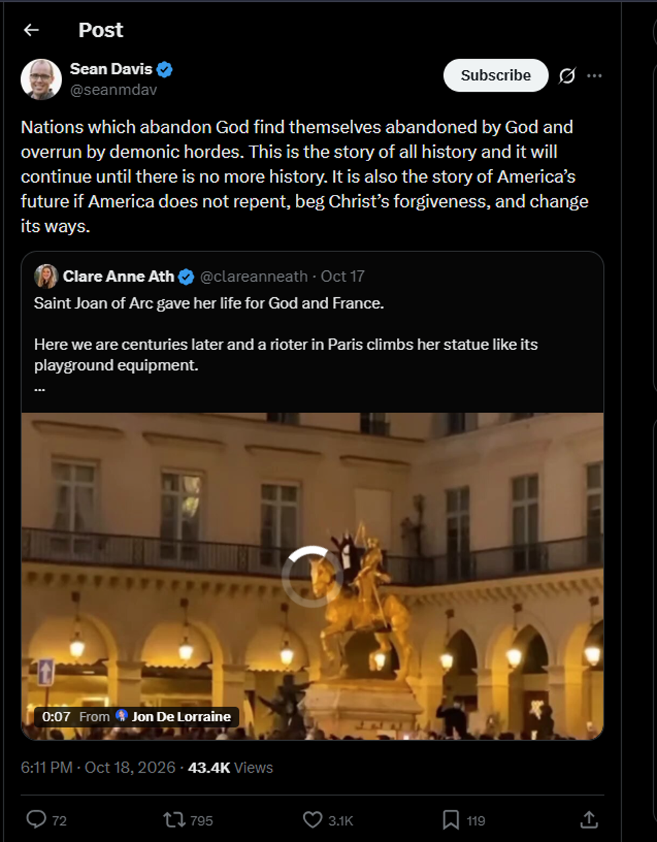
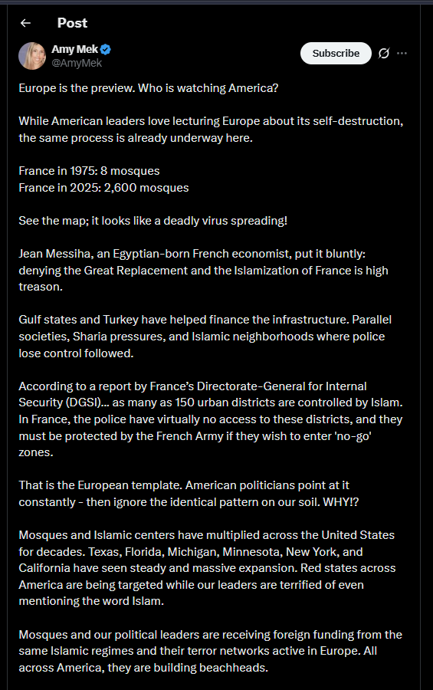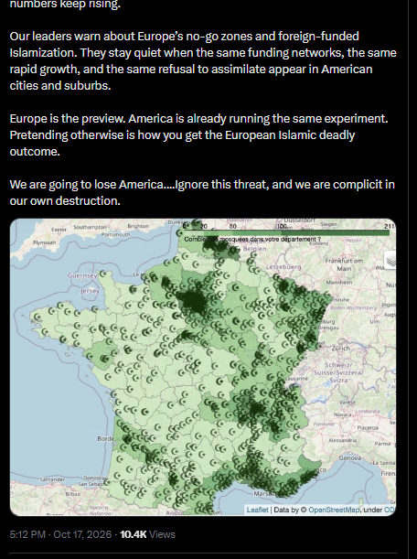

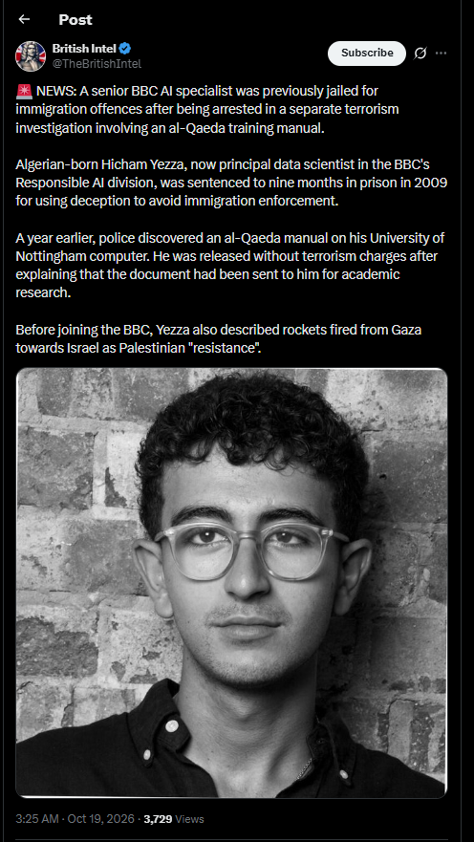
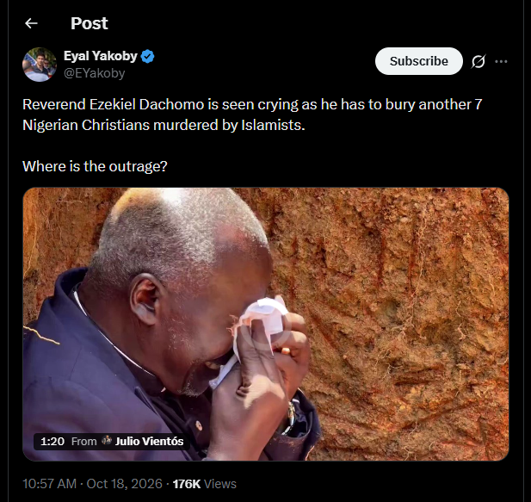

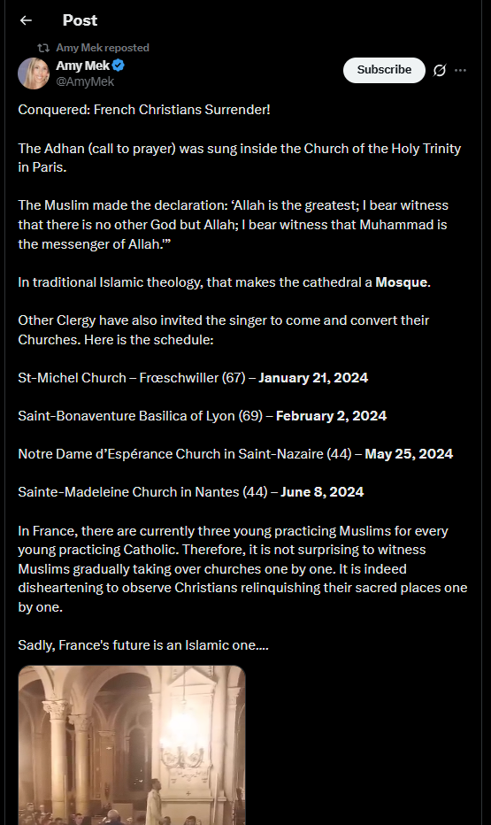


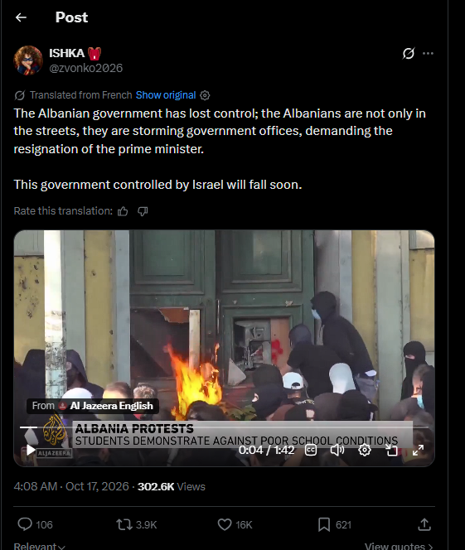

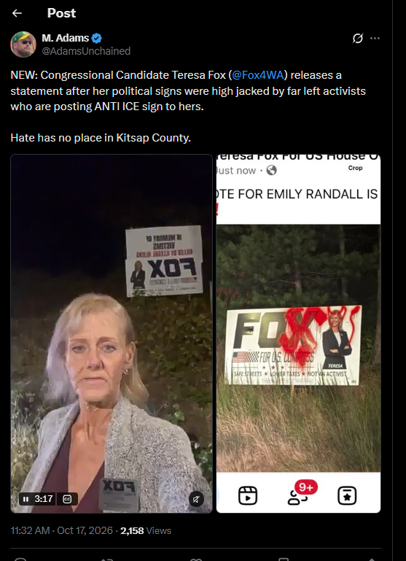

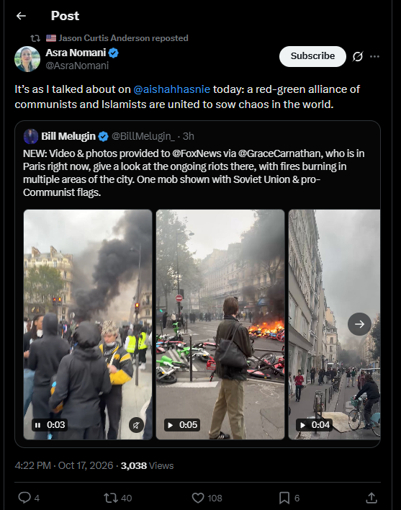

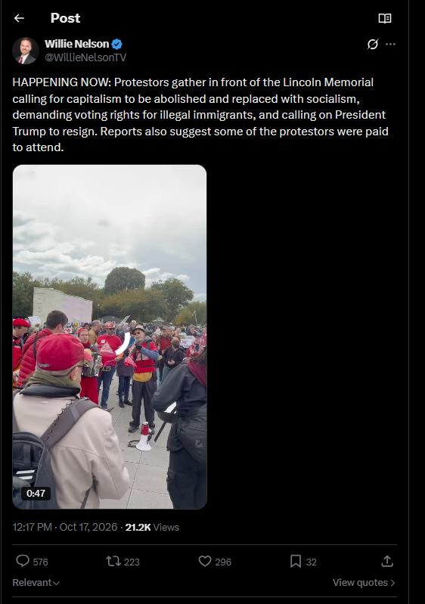
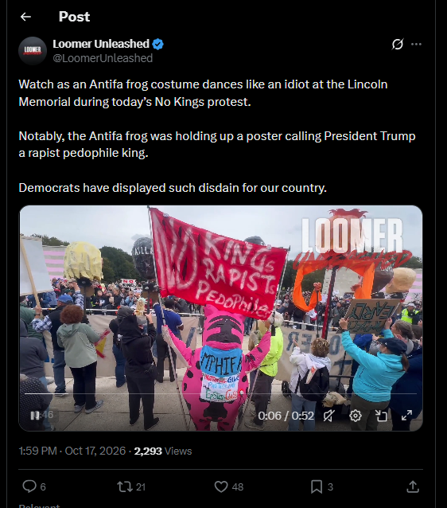

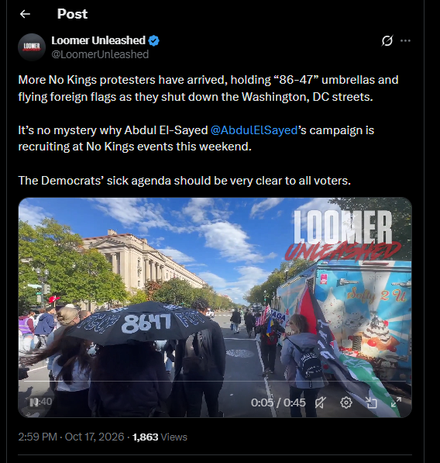

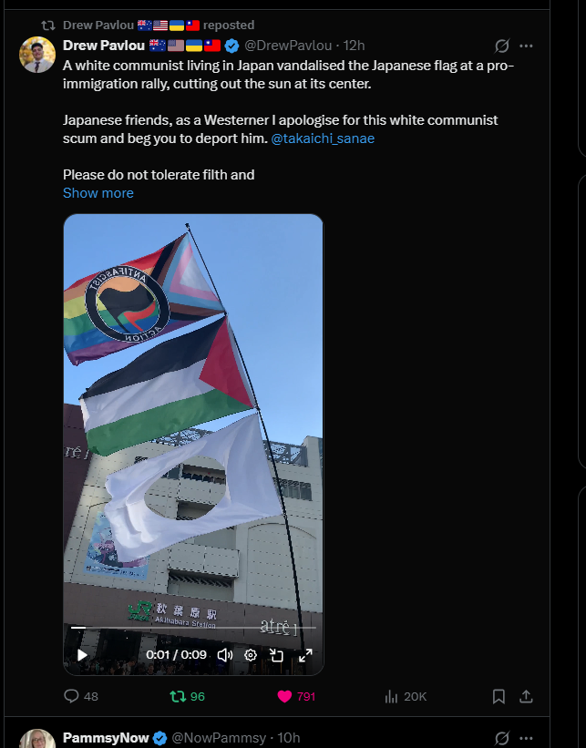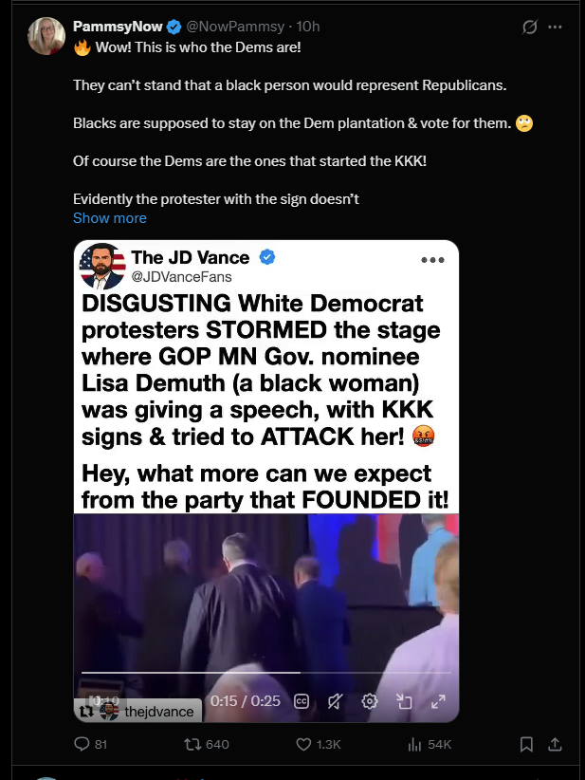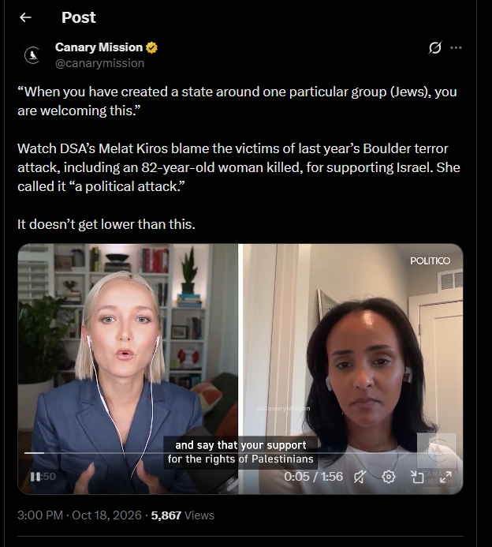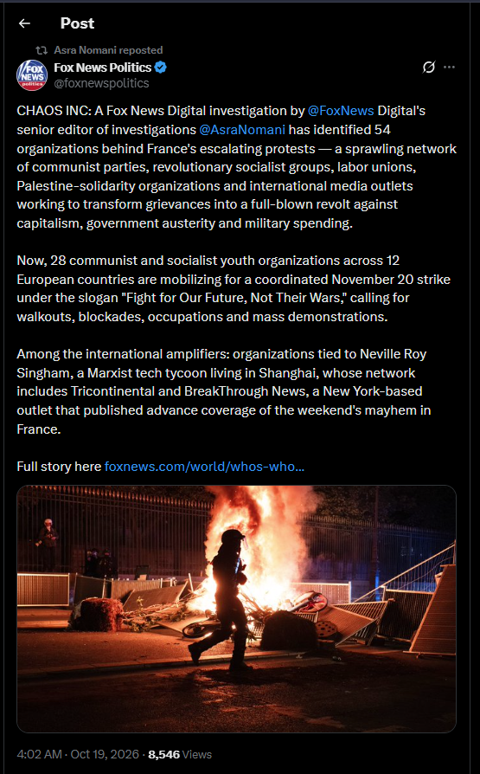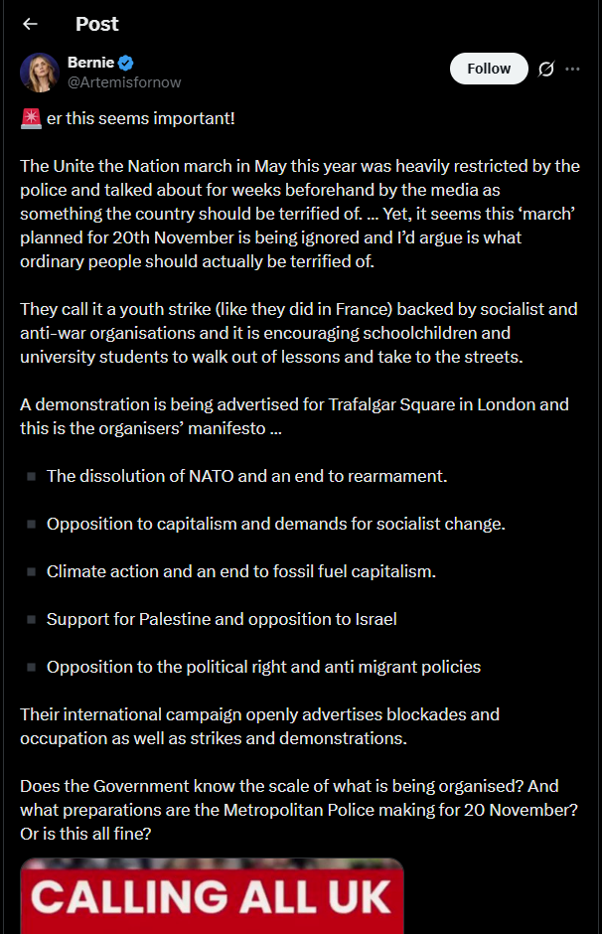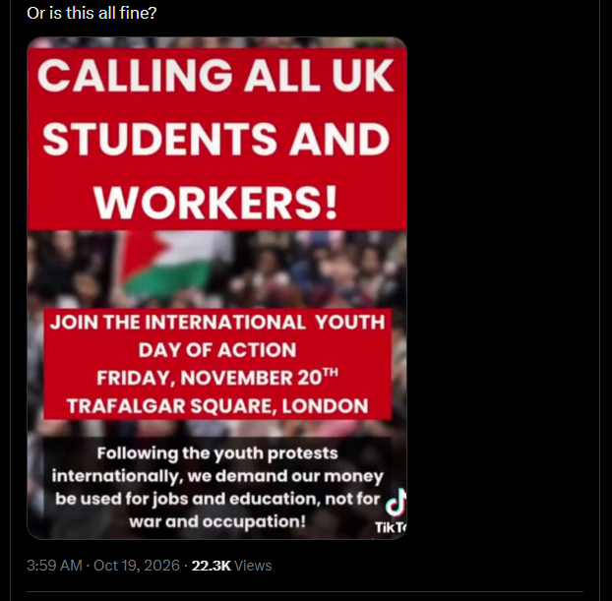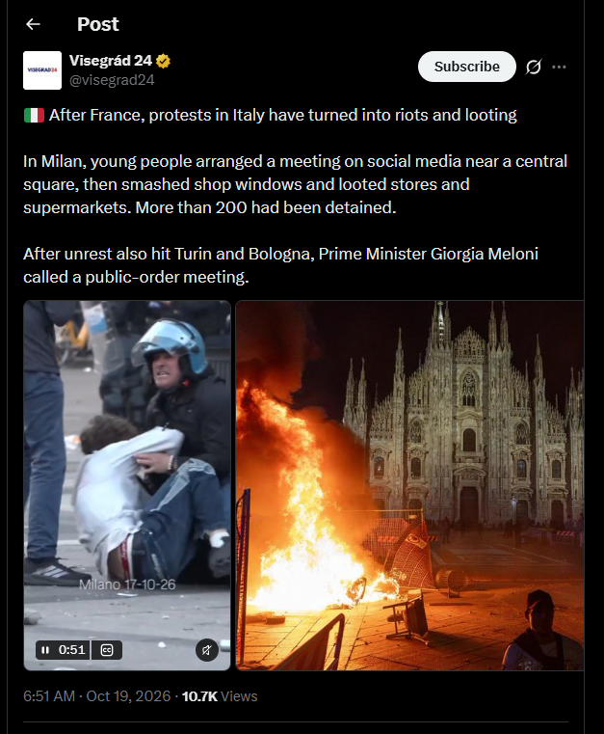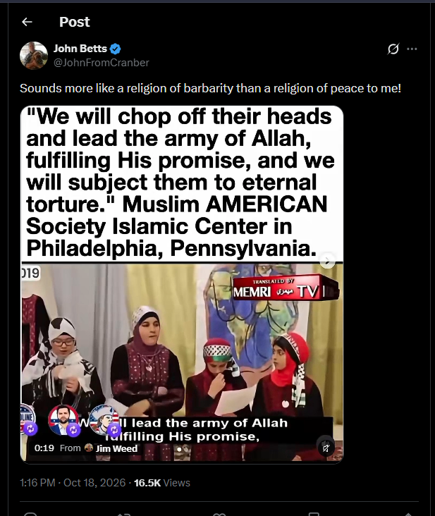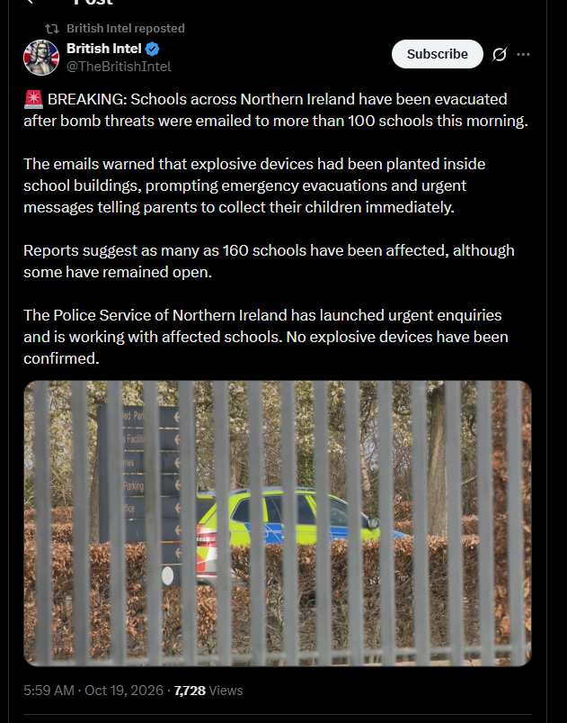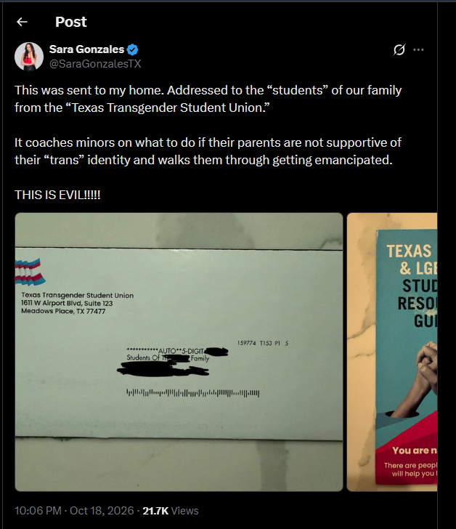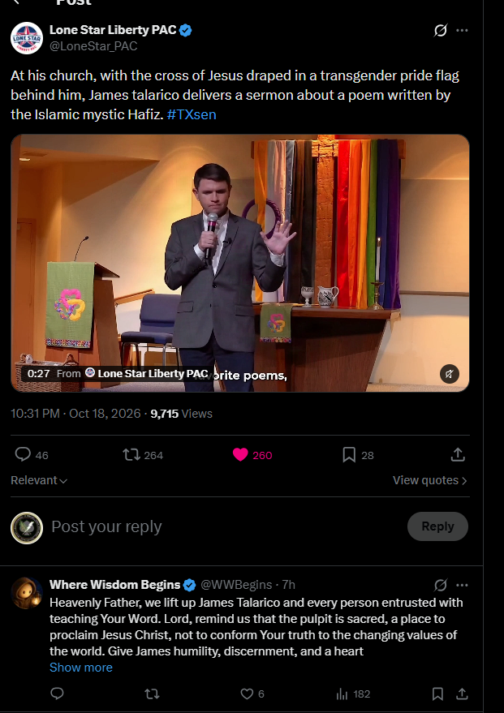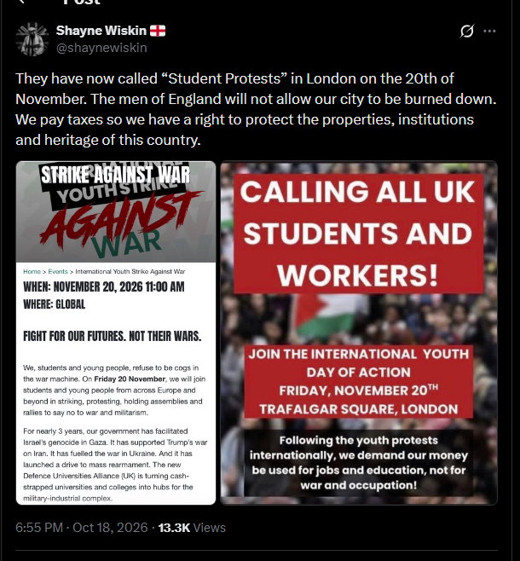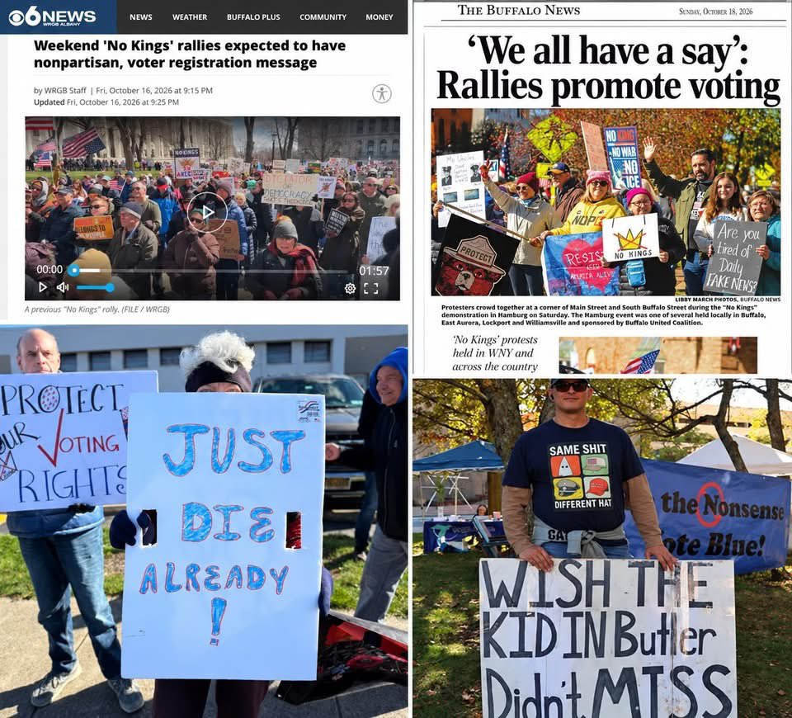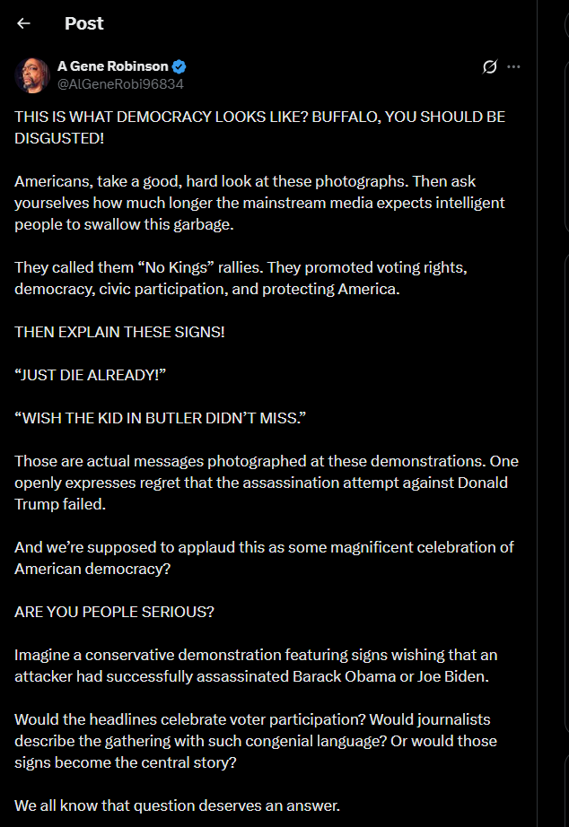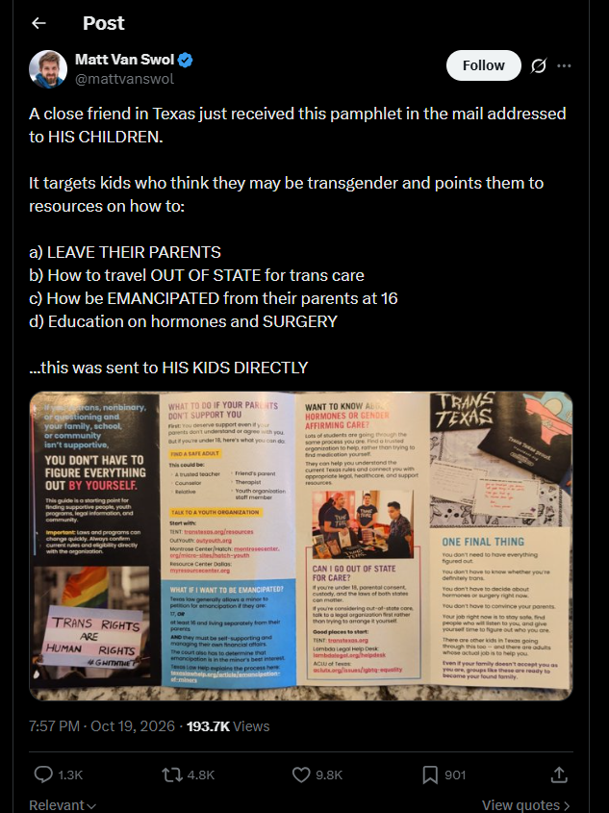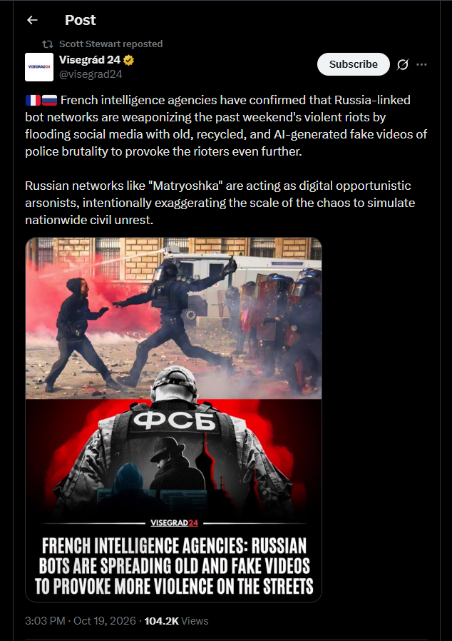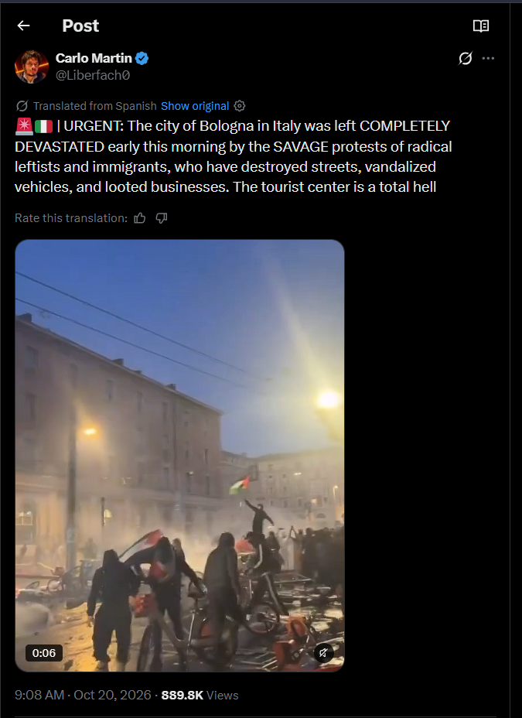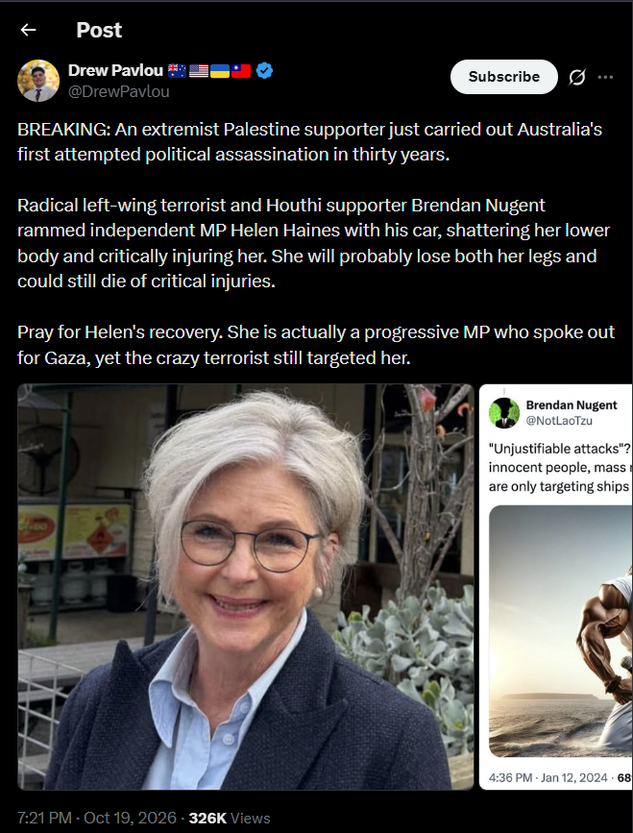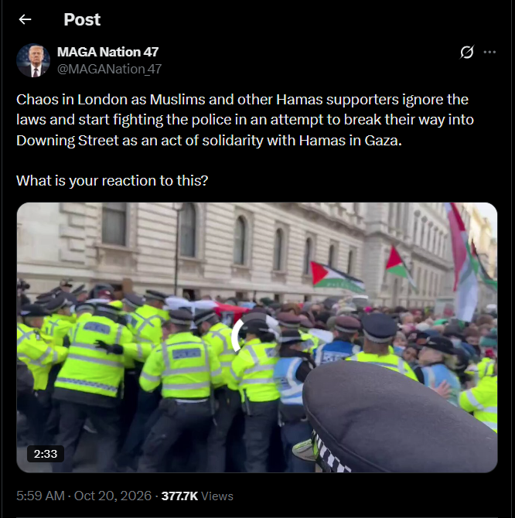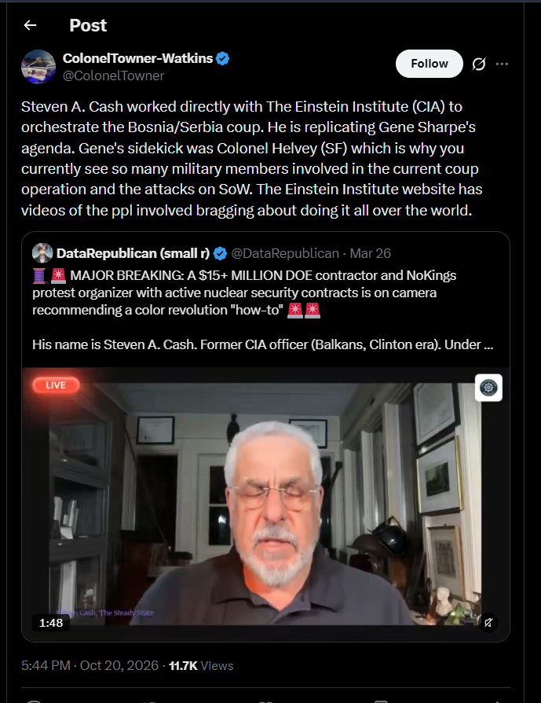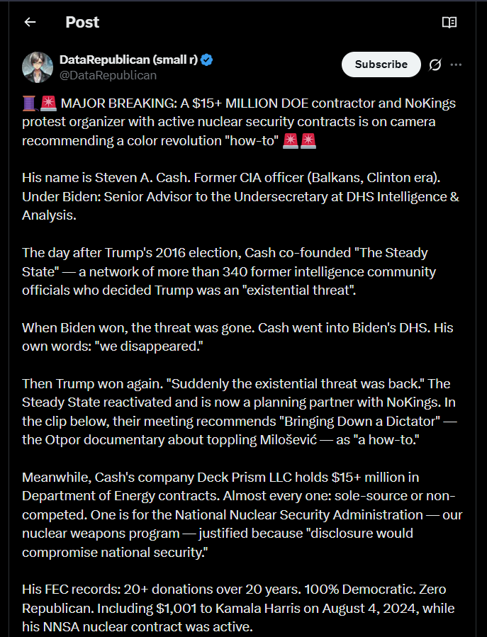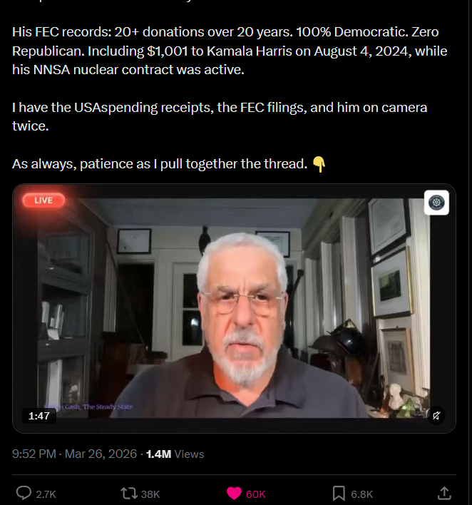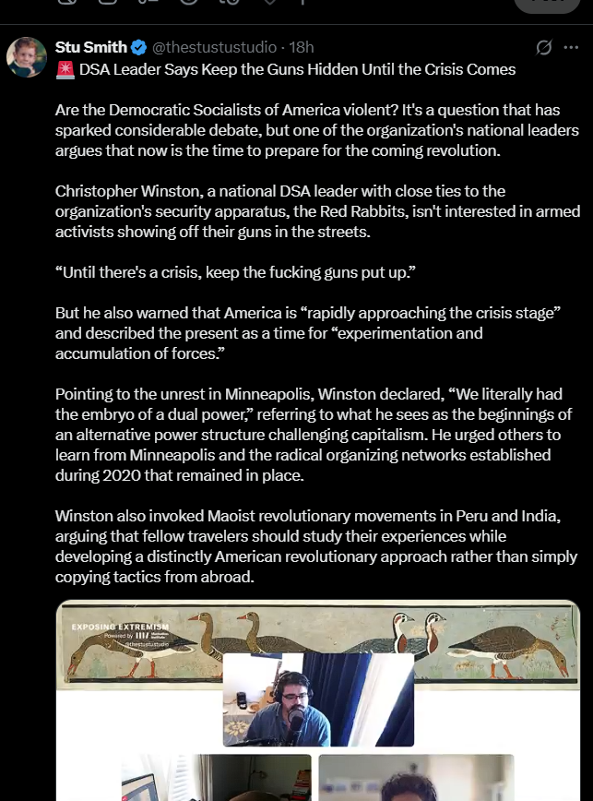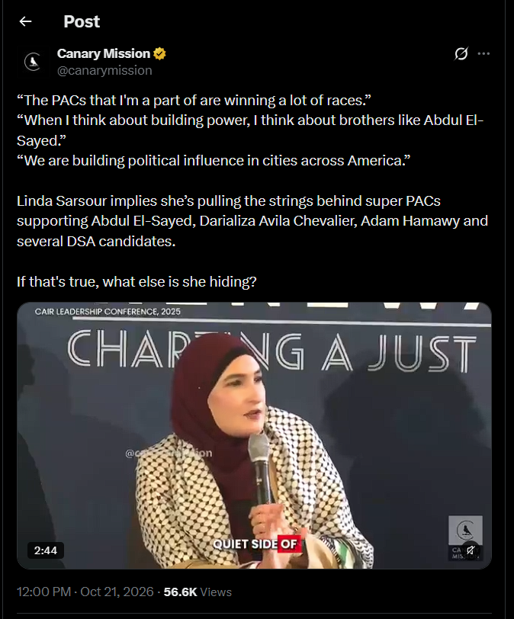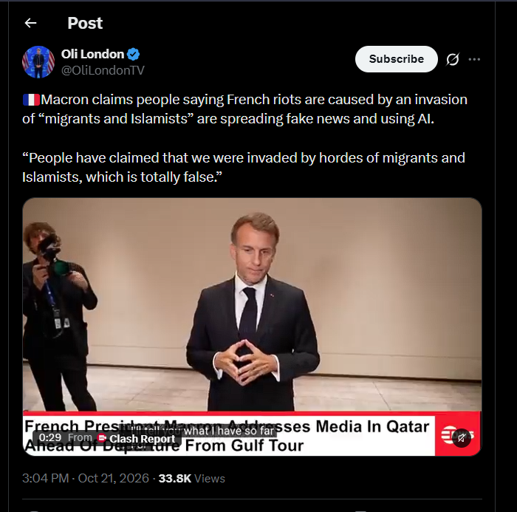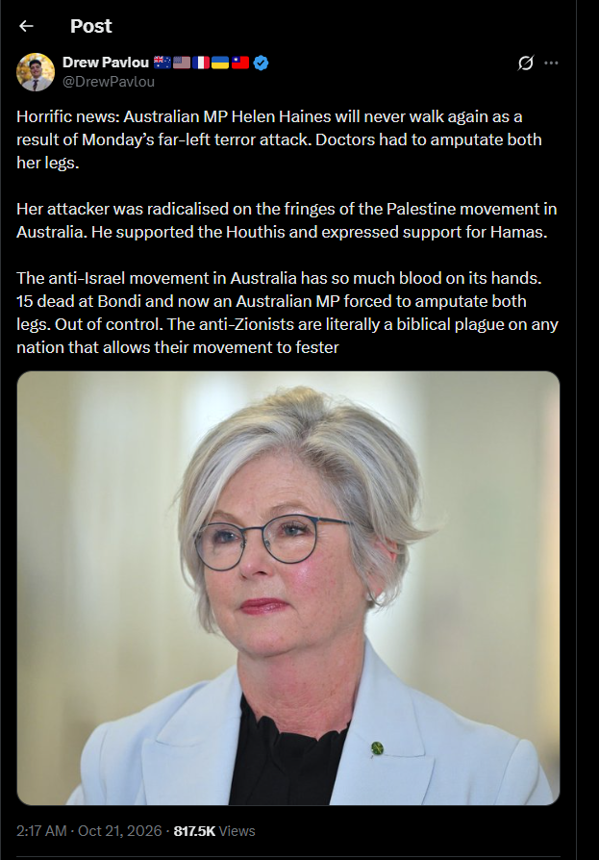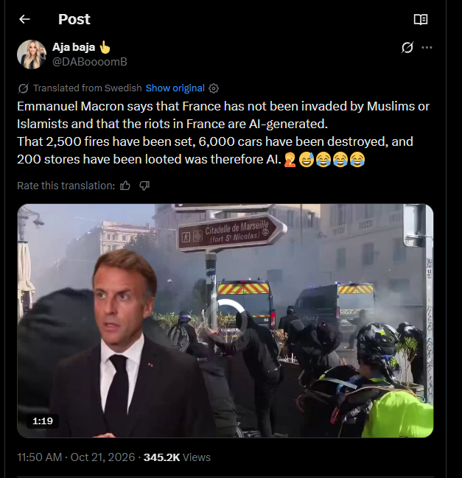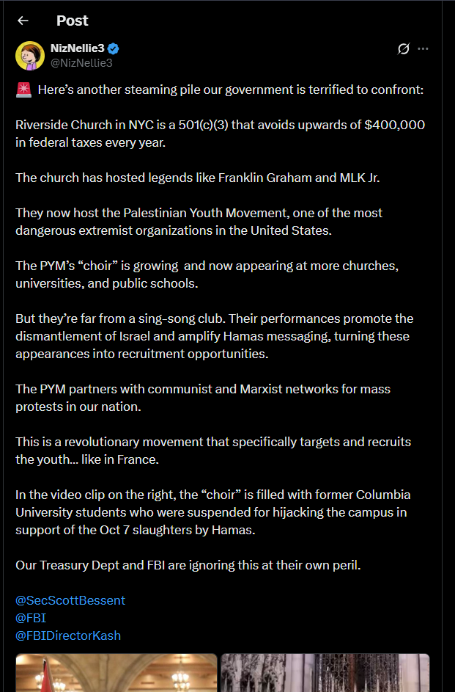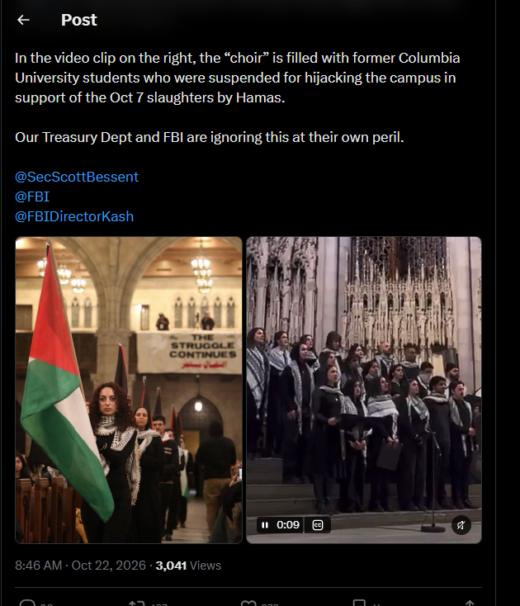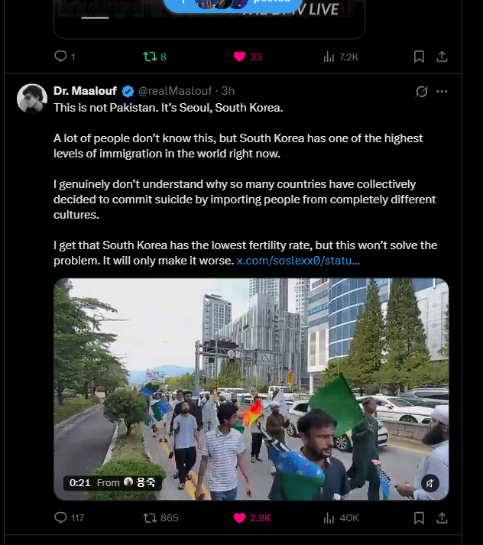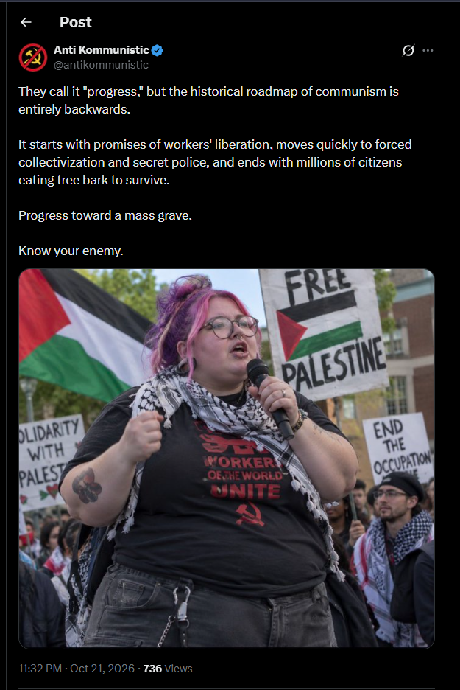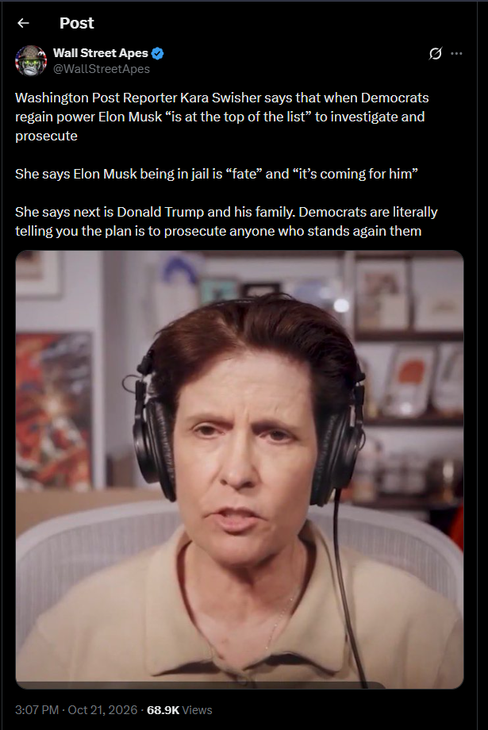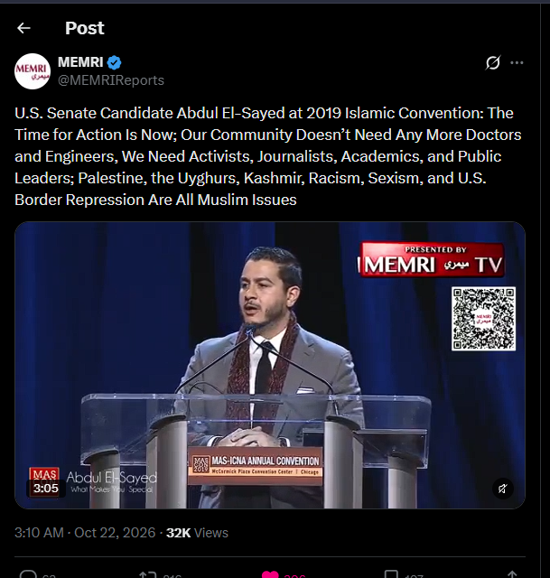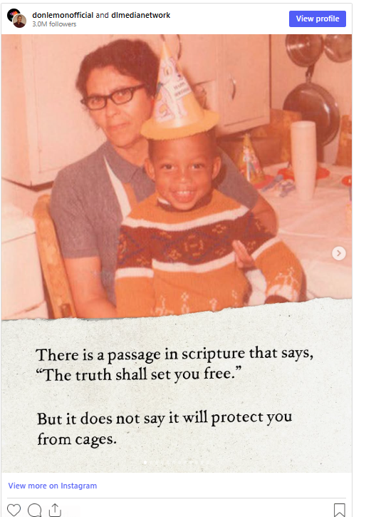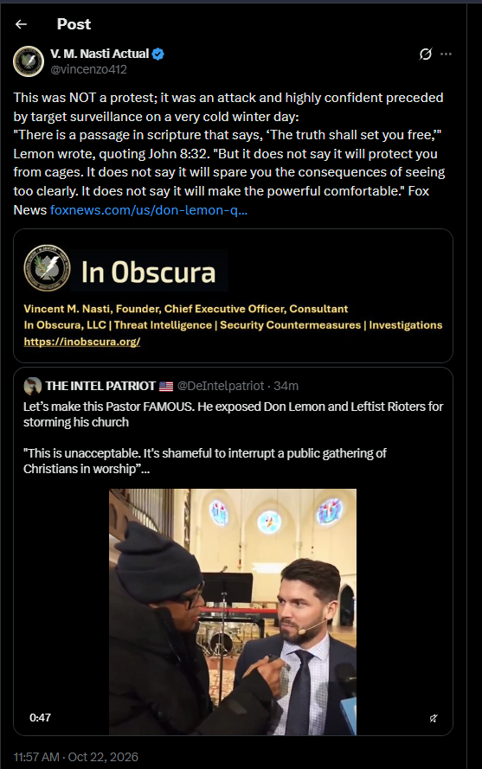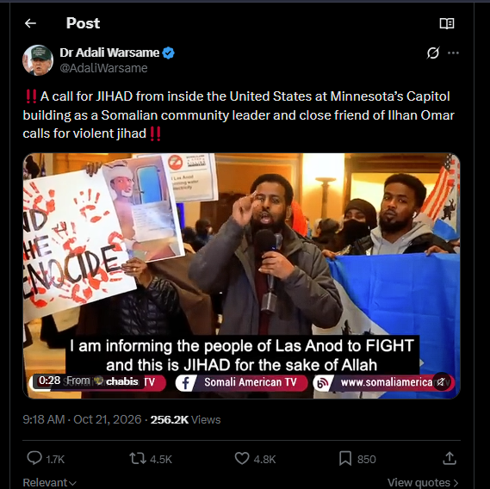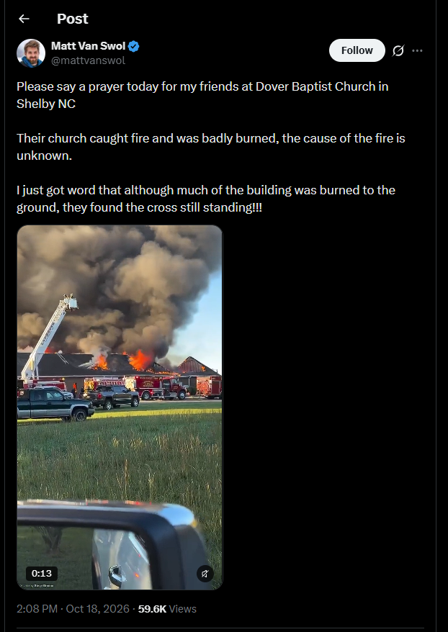

///END///
====================================================================
REQUEST WRITTEN PERMISSION, EMAIL, PRIOR TO DISSEMINATING ANY IN OBSCURA PRODUCTS OR INFORMATION. TRAFFIC LIGHT PROTOCOL REQUIREMENTS FOR DISSEMINATION
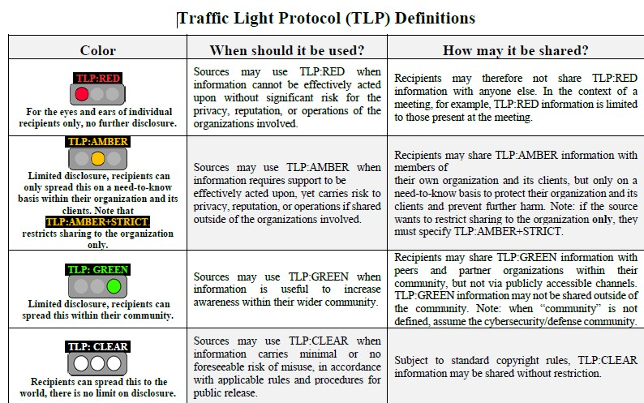
///END OF REPORT///

